# S2010 MT 1

1. Int 21h, Function 09h requires three things set up before calling in order to correctly print a string, Hello_msg. They are:

**DS = SEG Hello_msg, DX=OFFSET Hello_msg, Hello_msg terminated with 36**

2. Moore’s Law has accurately predicted the growth rate in the number of transistors per die for the last 40 years. What is the rate?

**Doubling every 18 – 24 months**

3. Given:

AX=0353 BX=0534 CX=0000 DX=0180 SP=FFEE BP=0000 SI=0000 DI=0000

DS=1D72 ES=1D72 SS=1D72 CS=1D72 IP=0109 OV UP EI PL NZ NA PO CY

1D72:0109 7D06 JNL 0118

What will the IP value be after a “t” command is executed in DOS Debug?

**010B**

4. A “NOP” instruction will:

**Perform a No OPeration**

5. Given:

AX=F247 BX=0000 CX=0000 DX=0000 SP=FFEE BP=0000 SI=0000 DI=0000

DS=1D72 ES=1D72 SS=1D72 CS=1D72 IP=0106 NV UP EI NG NZ NA PE NC

1D72:0106 EB0F JMP 0118

What will the IP value be after a “t” command is executed in DOS Debug?

**0118h**

6. In x86 architecture, BIU stands for which of the following?

**Bus Interface Unit**

7. Determine the contents of register BL after the following instructions have been executed:

**2EH**

7 Determine the contents of register BL after the following instructions have been executed:

**2EH** Program Listing

MOV BL, E2H

MOV CL, 1000b

ROL BL, CL

8. The number of bytes in a double word are:

**4**

9. In x86 architecture, ALU stands for which of the following?

**Arithmetic Logic Unit**

10. The “LOOPNE” instruction is equivalent to which of the following instructions?

**DEC CX, JNE**

11. The instruction MOV CX, DADD is what addressing mode?

**Immediate**

12. Here is a short sequence of code: 7413EBA3CD167D213C04EBF0EB15. All of the instructions are a word long. The third instruction operator is:

**INT**

12. Here is a short sequence of code: 7413EBA3CD167D213C04EBF0EB15. All of the instructions are a word long. The forth instruction operator is:

**JGE**

12. Here is a short sequence of code: 7413EBA3CD167D213C04EBF0EB15. All of the instructions are a word long. The fifth instruction operator is:

**CMP**

13. Which of the following DOS Debug instructions would set a break point at memory location 010C?

**G = 100 10C**

14. How many bytes are there in this short sequence of code? B400CD164CCD21

**7**

15. How many address lines would be required to address 128 MB directly?

**27**

16. What are the contents of CX after this program has been run:

**D800h**

17. 1010 0110 in 2’s complement equals____ in base 10.

**-90**

18. What is the hexadecimal encoding for adding AX with BX and storing the result in AX?

**01D8**

19. What is 11.437510 in binary?

**001011.01110**

20. If CX is 0000 what will CX be after a “LOOP” instruction?

**FFFF**

21. What is the hexadecimal encoding for “JGE” for a jump back 12 bytes?

**7DF2**

22. Given:

AX=FFE0 BX=3534 CX=0000 DX=0180 SP=FFEE BP=0000 SI=0000 DI=0000

DS=1D72 ES=1D72 SS=1D72 CS=1D72 IP=010E OV UP EI PL NZ NA PO NC

1D72:010F 7D08 JGE 0115

How many bytes will the processor jump if the conditions for a jump were met?

**7 if not an option pick 8**

23. What command in DEBUG would be used to execute interrupts?

**P**

24. What is the advantage of C Language over Assembly Language?

**C is transportable to other microprocessor architectures**

25. In adding 5+5 through a 4 but integer unit. The state of the OF and CF flags after the add instruction would be:

**OF = 1, CF = 0**

26. In MASM, with a “MOV CX, 24” instruction, and a “LOOP” instruction, in decimal how many times will the program loop?

**36**

27. Given:

AX=0353 BX=3534 CX=0000 DX=0180 SP=FFEE BP=0000 SI=0000 DI=0000

DS=1D72 ES=1D72 SS=1D72 CS=1D72 IP=010D NV UP EI PL NZ NA PO NC

1D72:010D 7DF6 JNL 0116

**-10**

28. AND’ing 1FH and 20H will result in which of the following?

**0**

29. The letters “NO” labeled on relays and PLCs means which of the following?

Normally open

13A7:0110 CD 20 32 20 54 48 39 73-20 69 73 20 74 68 65 20

13A7:0120 66 69 72 73 74 20 4D 69-64 74 65 72 6D 0D 24 D9

13A7:0130 00 C6 00 00 00 00 00 00-00 00 00 00 00 00 00 00

An input buffer is at memory location 0115, what is the size of the buffer in decimal?

**72**

30. A microprocessor with a 31-bit address bus could access how much memory?

**2 GB**

31. For the instruction sequence below, determine the contents of the register AL after this program is executed:

**51H**

32. Given:

AX=FF00 BX=3534 CX=0000 DX=0180 SP=FFEE BP=0000 SI=0000 DI=0000

DS=1D72 ES=1D72 SS=1D72 CS=1D72 IP=0109 OV UP EI PL NZ NA PO CY

1D72:0109 7D06 JNL 0118

What is the signed decimal value of the number in the AX register?

**-256**

33. The ASCII codes for space, space, carriage return, line feed, end of string in decimal are:

**32, 32, 13, 10, 36**

**What is -96.2697 converted to single precision FP?**

**C2 c0 8A 16**

**What is C2 Co 8a 16 Hex single precision FP converted to Decimal**

**-96.2697**

**Ieee converter**

**http://www.h-schmidt.net/FloatConverter/IEEE754.html**

# S2010 MT2

1. How many bit(s) is/are required to represent a range of decimal numbers from 0 to 99?

**7**

2. If CX is 0003, what will CX be after a “LOOP” instruction?

**0002**

3. IN the Propeller microcontroller, the command “waitcnt(clkfreq*5 + cnt)” would cause the processor to do which of the following?

**A 5 second delay**

4. What is the number 1011.01012 in decimal?

**11.31**

5. This section of memory represents a stack. What type of program is this?

BEEF : FFD0 00 00 00 00 00 00 00 00-00 00 00 00 00 00 00 00

BEEF : FFE0 00 01 02 03 04 05 06 07-08 09 0A 0B 0C 0D 0E 0F

BEEF : FFF0 11 22 33 44 55 66 77 88-99 AA BB CC DD EE FF

**COM program**

6. With a POPA instruction, what will be the order of the accumulator, base, count, and data registers restored from the stack?

**BDCA**

7. Determine the contents of register BL after the following instruction have been executed:

**2EH**

8. What Hex values must be sent to address the key pad rows on the PPE board?

**1, 2, 4, 8**

9. What is the number 32.437510 in binary?

**100000.01110**

10. In MASM, with a “MOV CX, 18h” instruction, and a “LOOP” instruction, in decimal how many times will the program loop?

**24**

11. The acronym PWM used for motor control, is defined as which of the following?

**Pulse Width Modulation**

12. In the PIC18 with TRISD = 0b01111111, what is the configuration of the Port D?

**Bit 7 of port D is set to input**

12. In the PIC18 with TRISD = 0b11111111, what is the configuration of the Port D?

**Bit 8 of port D is set to input**

13. Given the short code, what is the value in AX after the program is run?

**0500**

13. Given the short code, what is the value in AX after the program is run?

**0100**

14. What flag(s) does the “LOOPNZ” instruction look at to determine whether to loop or not?

**ZF**

15. How many nibbles are in double precision IEEE floating point format number?

**16**

**16. How many nibbles are in extended precision IEEE floating point format numbers (ttl10h)?**

**20**

17. What type of program is this?

AX=0000 BX=0000 CX=0000 DX=0180 SP=FFEE BP=0000 SI=0000 DI=0000

DS=1476 ES=1576 SS=1376 CS=1D72 IP=0015 NV UP EI PL NZ NA PO NC

1376:0015 0100 ADD [BI + SI], AL DS : 0000=CD

**EXE**

18. If the SP is F00F, what is the SP value after a “PUSH CX” instruction?

**F00D1**

19. In the PIC18 with TRISD = 0b00001111 and LATD = 0xAA, what value will be on Port D and shown on the LEDs?

**A0**

20. What is the numeric sequence of the key pad columns on the PPE board?

**37, 2F, 1F**

21. What is –130 decimal in 2’s complement (8bits)?

**01111110**

22. Which of the following is a valid x86 command for multiplying a number?

**MUL BX**

23. The number of bits in single precision IEEE floating point format are:

**32**

24. You are trying to rebuild a HELLO project program in MASM and you get the following error:

“LINK : warning L4021: no stack segment”.

What would be the reason for such an error?

**No project template for COM was selected**

25. A “pull down” resistor is used in digital circuits to do what?

**To keep the signal line “tied” low until the line is active (goes high)**

26. A “POP” instruction:

**increments the SP**

27. AND’ing 10H and 2FH will result in which of the following?

**0**

28. In the Propeller microcontroller, the command “dira[4..9] := %111111” would cause the processor to do which of the following?

**Sets the Propeller pins P4 through P9 as output pins**

29. What commands in MASM-CodeView would be used to step through a program line by line?

**T (F8)**

30. If the SP is F00F, what will the SP value be after a “POP SP” instruction?

**F011**

31. On the PPE board, what number(s) on the key pad is(are) pressed for an output port value of 08h and an input port value of 2Fh?

**0**

32. In the Propeller microcontroller, the term “Method” is(are) which of the following?

**A block of executable commands that has variables, can receive parameters, and returns a value.**

33. Using MASM, which of the following will cause a program with a LOOP instruction to loop 48 times in decimal?

**MOV CX, 30H or MOV CX, 48**

34. A “pull up” resistor is used in digital circuits to do what?

**To keep the signal “tied” high until the line is active (goes low)**

EEE-174 MT1

1. What is the hexadecimal encoding for "JNL" for a jump back 8 bytes?

0F F8

2. In X86 architecture, ALU stands for which of the following?

Arithmetic Logic Unit

3. The number of nibbles in a word are:

16/4 = 4

4. The instruction MOV BX, [2BAD] is what addressing mode?

Direct

5. What is the hexadecimal encoding for adding DX with BX and storing the result in BX?

O1CB

6. A microprocessor with a 32-bit address bus could access how much memory?

2^4=16MB , 2^8=256KB, 2^32=4GB

7. You add 7+6 through a 4 bit integer unit. The state of the OF and CF flags after the add will be:

0111 1 OF=1, the sign bit has changed

+0110 CF=1,there is a carryon of bit 7

0|1101

8. Which of the following DOS Debug instructions would be used change the IP register to 100?

RIP

Convert 129.C hexadecimal into decimal

297.75 *note after decimal divide by 16

8.1 What is the RS232C, specification voltage range for the Logic 0 output?

+3v to +25v.

8.1 What is the RS232C, specification voltage range for the Logic 1 output?

-3v to -25v.

9. What are the contents of CX after this program has been run:

|  |  |
| --- | --- |
| Memory location | Contents |
| 5514 | 24 |
| 5513 | D8 |
| 5512 | 00 |
| 5511 | 21 |

MOV DX, 11h

MOV CX, [5512]

MOV BX, 5511h

SUB DX, [BX]

0000h

***What are the contents of DX after this program has been run:

FFF0h

9. What are the contents of BX after this program?

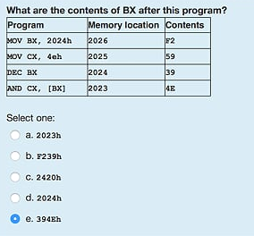

Assuming DS = 1000h, the instruction sequence in the listing below takes the last byte in the transfer from memory at:

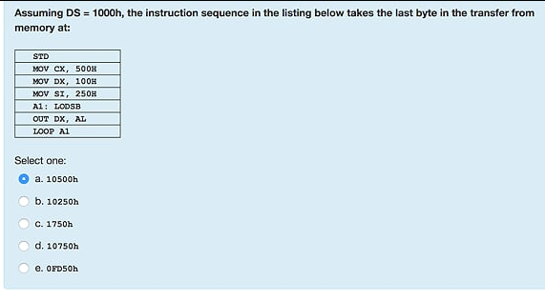

A microprocessor with a 26-bit address bus could access how much memory?

64MB

10. Given:

AX=FFD0 BX=3534 CX=0000 DX=0180 SP=FFEE BP=0000 SI=0000 DI=0000

DS=1D72 ES=1D72 SS=1D72 CS=1D72 IP=0109 OV UP EI PL NZ NA PO CY

1D72:0109 7D06 JNL 0118

What is the signed decimal value of the number in the AX register?

-48

11. How many bytes are there in this short sequence of code? B815B400CD16CD20

8

12. In using INT 10h to set the video code to 640x350,what value must be in the AH register?

AX

AH|AL

00

00h

13. Moore's law has accurately predicted the growth rate in the number of transistors per die for the last 25 years. What is that rate?

Doubling every 18-24 months

14. INT 21h, Function 09h requires three things set up before calling in order to correctly print a string,

Hello_msg. They are:

DS=SEG Hello_msg, DX=OFFSET Hello_msg, Hello_msg terminated with 24h

15. Given

13A7:0110 CD 20 32 20 54 68 69 73-20 69 73 20 74 68 65 20

13A7:0120 66 69 72 73 74 20 4D 69-64 75 65 72 6D 0D 24 D9

13A7:0130 00 C6 00 00 00 00 00 00-00 00 00 00 00 00 00 00

An input buffer is at memory location 0112, what is the size of the buffer in decimal?

50

An input buffer is at memory location 0118, what is the size of the buffer in decimal?

32 **if 0118 is 50 then answer is 80**

16. Here is a short sequence of code: 7413CD16EB157D213C04EBF0A3C6. All of the instructions are two bytes long. The third instruction operator is: EB15

JMP

17. What is the hexadecimal encoding for loading DX with a word (value) from memory location 0820h?

8B162008

18. Given:

AX=FFE0 BX=3534 CX=0000 DX=0180 SP=FFEE BP=0000 SI=0000 DI=0000

DS=1D72 ES=1D72 SS=1D72 CS=1D72 IP=010D OV UP EI PL NZ NA PO NC

1D72: 010D 7D09 JGE 0116

How many bytes will the processor jump if the condition for a jump were met?

9

19. F6 in 2's complement equals _______in base 10.

-10

21. Determine the contents of register BH after the following instructions have executed:

70h MOV [0202], AX

22. Given:

AX=2247 BX=0000 CX=0000 DX=0000 SP=FFEE BP=0000 SI=0000 DI=0000

DS=1D72 ES=1D72 SS=1D72 CS=1D72 IP=0106 NV UP EI NG NZ NA PE NC

1D72: 0106 EB0F JMP 0118

What will be the IP value be after a "t" command is executed in DOS Debug?

0118h

23. Which of the following DOS Debug instructions would set a break point at memory location 010E?

G=100 10E

24. Given:

0B0E: 0200 57 65 6C 63 6F 6D 65 20-74 6F 20 41 73 73 65 6D

0B0E:0210 62 6C 79 20 4C 61 6E 67-75 61 67 65 00 00 00 00

An ASCII message begins at memory location 0200, what is the message?

Welcome to Assembly Language

25. Given:

AX=FF47 BX=0000 CX=0000 DX=0000 SP=FFEE BP=0000 SI=0000 DI=0000

DS=1D72 ES=1D72 SS=1D72 IP=0104 NV UP EI NG NZ NA PE NC

1D72:0104 7002 JO 0118

What will the IP value be after a "t" command is executed in DOS Debug?

0106h

26. Given:

AX=FFD0 BX=3534 CX=0000 DX=0180 SP=FFEE BP=0000 SI=0000 DI=0000

DS=1D72 ES=1D72 SS=1D72 CS=1D72 IP=010E OV UP EI PL NZ NA PO CY

1D72:0109 7D06 JNL 0118

What will the IP value be after a "t" command is executed in DOS Debug?

0110

27. The instruction MOV BX, 2BAD is what addressing mode?

Immediate

28. What is the hexadecimal encoding for "JNL" for a jump back 10 bytes?

7DF4

29. How many address lines would be required to address 64MB directly?

26 /2^26=67mb/

30. The number of nibbles in a double word are: 8

31. In using INT 10h to move the screen cursor to return on the same line, what value must be in the AX register?

0E0Dh

32. Given:

AX=FFD0 BX=3534 CX=0000 DX=0180 SP=FFEE BP=0000 SI=0000 DI=0000

DS=1D72 ES=1D72 SS=1D72 CS=1D72 IP=010D OV U EI PL NZ NA PO NC

1d72: 010D 7D09 JNLE 0118

What will the IP value be after a "t" command is executed in DOS Debug?

010Fh

33. Which of the following DOS Debug instructions would be used change the AX register?

RAX

34. How many Bytes are there in this short sequence of code? B815B400CD168A3CCD20

10

35. Given:

AX=FFD0 BX=3534 CX=0000 DX=0180 SP=FFEE BP=0000 SI=0000 DI=0000

DS=1D72 ES=1D72 SS=1D72 CS=1D72 IP=0111 NV UP EI NG NZ NA PO CY

1D72:0111 EB08 JMP 0119

What will the IP value be after a "t" command is executed in DOS Debug?

0119h

36.Given:

AX=FFD0 BX=3534 CX=0000 DX=0180 SP=FFEE BP=0000 SI=0000 DI=0000

DS=1D72 ES=1D72 SS=1D72 CS=1D72 IP=010E OV UP EI NG NZ NA PO CY

1D72: 010E 7D06 JNLE 0118

What will the IP value be after a "t" command is executed in DOS Debug?

0118

37. How many bytes decimal will the program jump for JNB instruction, given the following?

AX=0000 BX=0000 CX=0000 DX=0000 SP=FFEE BP=0000 SI=0000 DI=0000

DS=1376 ES=1376 SS=1376 CS=1376 IP=0100 NV UP EI PL NZ NA PO NC

1376:0100 73E0 JNB 00E2

-32

38. Given:

AX=FFE0 BX=3534 CX=0000 DX=0180 SP=FFEE BP=0000 SI=0000 DI=0000

DS=1D72 ES=1D72 SS=1D72 CS=1D72 IP=010D OV UP EI PL NZ NA PO NC

1D72: 010D 7F09 JNLE 0118

What is the decimal value of the signed number in the AX register?

-0032

39. How many address lines would be required to address 512 MB directly?

29 /2^9=29/

40. What is the hexadecimal encoding for adding BX with CX and storing the result in BX?

03CB or 03D9 -- 02CB or 02D9 - these are the only options

41. The binary number, 0111 1110, represents what values; in Hex, and as a BCD number?

7E, 7 invalid

42. In using INT 10h to set the vidio mode to 640 X 200, what value must be in the AX register?

0006h

43. what is the hexadecimal encoding for loading AH with a word from memory location 0520h?

8B262005 (choose 8B162005 if that is only option)

44. What is the hexadecimal encoding for "JGE" for a jump back 10 bytes?

7DF6

45. Given:

13A7:0110 CD 20 48 20 54 68 69 73-20 69 73 20 74 68 65 20

13A7:0120 66 69 72 73 74 20 4D 69-64 74 65 72 6D 0D 24 D9

13A7:0120 00 C6 00 00 00 00 00 00-00 00 00 00 00 00 00 00

An input buffer is at memory location 0112, what is the size of the buffer in bytes in decimal:

72

46. Given:

AX=FF47 BX=0000 CX=0000 DX=0000 SP=FFEE BP=0000 SI=0000 DI=0000

DS=1D72 ES=1D72 SS=1D72 CS=1D72 IP=0106 NV UP EI NG NZ NA PE NC

1D72:0104 7002 JNO 0118

What will the IP value be after a "t" command is executed in DOS Debug?

0118

47. Determine the contents of register AH after the following instruction have executed:

MOV BX,BA70H

MOV AX,47E7H

MOV BL, 0FH 47H

AND AL,BL

MOV [0202], AX

48. In using INT 10h to move the screen cursor to return to the beginning of the line, what value must be in the AX register?

0E0Dh

49. Given:

1376:0110 48 61 76 65 20 61 20 67-72 65 61 74 20 53 70 72

1376:0120 69 6E 67 20 52 65 63 65-73 73 21 00 00 00 00 00

An ASCII message begins at memory location 0110, what is the message?

Have a great Spring Recess!

50. You add 1+8 through a 4 bit integer unit. The state of the OF and CF flags after the ad will be:

OF=0, CF=0

Page 16

51. What is the advantage of Assembly Language over C Language?

The Assembler creates much faster executable code

52. In The X86 lab 3 Hello MASM program in the original code, what is the address of the byte used to start the number in the sequence "Hello World 0"?

020E

53. Which of the following DOS Debug instructions would set a break point at memory location 010C?

G = 100 10C

54. If CX is 0000 what will CX be after a "LOOP" instruction?

FFFF

55. Given:

AX=0353 BX=0534 CX=0000 DX=0180

DS= 1D72 IP=0109 OV UP EI PL NZ NA PO CY

1D72:0109 7D06 (OV=1,NV=1 ZR=1, NZ=0)

010B

56. How many core does the propeller microcontroller have?

8

57. What is the hexadecimal encoding for "JGE" for a jump back 12 byes?

7DF2 (marked right) though maybe 7DF4

58.Here is a short sequence of code: 7413EBA3CD167D213C04EBF0EB15. instructions are a word long. The third instruction operator is:

INT

59. In MASM, with a "MOV CX, 24" instruction, and a "LOOP" instruction, in decimal how many times will the program loop?

24

60. The ASCII codes for space , space, carriage return, line feed, end of string in decimal are:

32,32,13,10,36

61. A "NOP" instruction in a program will:

Perform a No Operation

62. How many address lines would be required to address 64MB directly?

26

63. What command in DEBUG would be used to execute interrupts?

P

64. What high level language is the propeller programmed in?

Spin

65. Which of the following DOS Debug instruction would be used to change the IP register to 010C?

RIP

66. The acronym PWM used in the Parrallax Propeller and MicroChip PIC18, is defined as:

Pulse Width Modulation

67. Which command would you use to execute another core in the propeller microcontroller?

Cognew

68. Given: IP=0111 NV UP EI NG NZ NA PO CY

1D72:0111 JMP 0119

What will the IP value be after a "t" command is executed in DOS Debug?

0119h

69. The instruction MOV CX, DADD is what addressing mode?

Immediate

69. The instruction MOV CX, [DADD] is what addressing mode?

Direct

70. In the PIC18 with TRISD = 0b00001111 and LATD = 0xAA, what value will be on Port D and shown on the LEDs?

A0

71. In the Propeller microcontroller, the command "dira[4..9] := %111111" would cause the processor to do with of the following?

Sets the Propeller pins P4 through P9 as output pins

72. In the Propeller microcontroller, the command "waitcnt(clkfreq*10 + cnt)" would cause the processor to do with of the following?

Create 10 second delay

73. The "LOOPNE" instruction is equivalent to which of the following instructions?

DEC CX, JNE

74. On the Arduino platform, what is the programming language used?

C

EEE 174 Midterm Study Guide

# S2010 MT 1

1. Int 21h, Function 09h requires three things set up before calling in order to correctly print a string, Hello_msg. They are:
   1. **DS = SEG Hello_msg, DX=OFFSET Hello_msg, Hello_msg terminated with 36**

**Or the other option in hex is below**

* 1. **DS = SEG Hello_msg, DX=OFFSET Hello_msg, Hello_msg terminated with 24h**

1. Moore’s Law has accurately predicted the growth rate in the number of transistors per die for the last 40 years. What is the rate?
   1. **Doubling every 18 – 24 months**
2. Given:

AX=0353 BX=0534 CX=0000 DX=0180 SP=FFEE BP=0000 SI=0000 DI=0000

DS=1D72 ES=1D72 SS=1D72 CS=1D72 IP=0109 OV UP EI PL NZ NA PO CY

1D72:0109 7D06 JNL 0118

What will the IP value be after a “t” command is executed in DOS Debug?

* 1. **010B**

1. A “NOP” instruction will:
   1. **Perform a No OPeration**
2. Given:

AX=F247 BX=0000 CX=0000 DX=0000 SP=FFEE BP=0000 SI=0000 DI=0000

DS=1D72 ES=1D72 SS=1D72 CS=1D72 IP=0106 NV UP EI NG NZ NA PE NC

1D72:0106 EB0F JMP 0118

What will the IP value be after a “t” command is executed in DOS Debug?

* 1. **0118h**

1. In x86 architecture, BIU stands for which of the following?
   1. **Bus Interface Unit**
2. 7. Determine the contents of register BL after the following instructions have been executed:
   1. **2EH**
3. 8. The number of bytes in a double word are:
   1. **4**
4. In x86 architecture, ALU stands for which of the following?
   1. **Arithmetic Logic Unit**
5. The “LOOPNE” instruction is equivalent to which of the following instructions?
   1. **DEC CX, JNE**
6. The instruction MOV CX, DADD is what addressing mode?
   1. **Immediate**
7. Here is a short sequence of code: 7413EBA3CD167D213C04EBF0EB15. All of the instructions are a word long. The third instruction operator is:
   1. **INT**
8. Which of the following DOS Debug instructions would set a break point at memory location 010C?
   1. **G = 100 10C**
9. How many bytes are there in this short sequence of code? B400CD164CCD21
   1. **7**
10. How many address lines would be required to address 128 MB directly?
    1. **27**
11. What are the contents of CX after this program has been run:
    1. **D800h**
12. 1010 0110 in 2’s complement equals____ in base 10.
    1. **-90**
13. What is the hexadecimal encoding for adding AX with BX and storing the result in AX?
    1. **01D8**
14. What is 11.437510 in binary?
    1. **001011.01110**
15. If CX is 0000 what will CX be after a “LOOP” instruction?
    1. **FFFF**
16. Given:

AX=FFE0 BX=3534 CX=0000 DX=0180 SP=FFEE BP=0000 SI=0000 DI=0000

DS=1D72 ES=1D72 SS=1D72 CS=1D72 IP=010E OV UP EI PL NZ NA PO NC

1D72:010F 7D08 JGE 0115

How many bytes will the processor jump if the conditions for a jump were met?

* 1. **8**

1. What command in DEBUG would be used to execute interrupts?
   1. **P**
2. What is the advantage of C Language over Assembly Language?
   1. **C is transportable to other microprocessor architectures**
3. In adding 5+5 through a 4 but integer unit. The state of the OF and CF flags after the add instruction would be:
   1. **OF = 1, CF = 0**
4. In MASM, with a “MOV CX, 24” instruction, and a “LOOP” instruction, in decimal how many times will the program loop?
   1. **36**
5. Given:

AX=0353 BX=3534 CX=0000 DX=0180 SP=FFEE BP=0000 SI=0000 DI=0000

DS=1D72 ES=1D72 SS=1D72 CS=1D72 IP=010D NV UP EI PL NZ NA PO NC

1D72:010D 7DF6 JNL 0116

* 1. **-10**

1. AND’ing 1FH and 20H will result in which of the following?
   1. **0**
2. Given:

13A7:0110 CD 20 32 20 54 48 39 73-20 69 73 20 74 68 65 20

13A7:0120 66 69 72 73 74 20 4D 69-64 74 65 72 6D 0D 24 D9

13A7:0130 00 C6 00 00 00 00 00 00-00 00 00 00 00 00 00 00

An input buffer is at memory location 0115, what is the size of the buffer in decimal?

* 1. **72**

1. A microprocessor with a 31-bit address bus could access how much memory?
   1. **2 GB**
2. For the instruction sequence below, determine the contents of the register AL after this program is executed:
   1. **51H**
3. Given:

AX=FF00 BX=3534 CX=0000 DX=0180 SP=FFEE BP=0000 SI=0000 DI=0000

DS=1D72 ES=1D72 SS=1D72 CS=1D72 IP=0109 OV UP EI PL NZ NA PO CY

1D72:0109 7D06 JNL 0118

What is the signed decimal value of the number in the AX register?

* 1. **-256**

1. The ASCII codes for space, space, carriage return, line feed, end of string in decimal are:
   1. **32, 32, 13, 10, 36**

**Spring 2012**

1. What is the advantage of assembly language over C language?
   1. The assembler creates much faster executable code
2. How many lines would be required to address 128 mb directly?
   1. 27
3. In the x86 lab part 3 Hello MASM program in the original code, what is the address of the byte used to start the number in the sequence “Hello World 0”?
   1. 020E
4. Given

W e l c o m e _ t o _ A s s e m

0B0E:0200 57 65 6C 63 6F 6D 65 20-74 6F 20 41 73 73 65 6D

0B0E:0210 62 6C 79 20 4C 61 6E 67-75 61 67 65 00 00 00 00

b l y _ L a n g u a g e

An Ascii message begins at memory location 0200, what is the message?

* 1. Welcome to Assembly Language

1. Which of the following DOS Debug instructions would be used to change the IP register to 0110?
   1. RIP
2. Moore’s law has accurately predicted the growth rate in the number of transistors per ide for the last 40 years. What is the rate?
   1. Doubling every 18 – 24 months
3. Which of the following DOS debug instructions would set a break point at memory location 010C?
   1. G = 1000 10C
4. AND’ing 1FH and 02H will result in which of the following?
   1. 02
5. If CX is 0000 what will CX be after a “LOOP” instruction?
   1. FFFF
6. The number of bits in a word are:
   1. 16
7. In x86 architecture, ALU stands for which of the following?
   1. Arithmetic Logical Unit
8. Given:

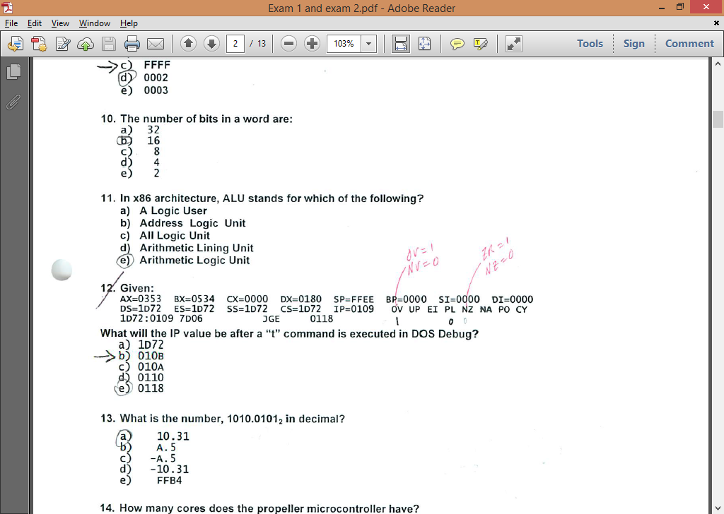

What will the IP value be after a “t” command is executed in DOS DEBUG?

* 1. 010B

1. What is the number 1010.01012 in decimal?
   1. 10.31
2. How many cores does the propeller microcontroller have?
   1. 8
3. What is the hexadecimal encoding for “JGE” for a jump back 12 bytes?
   1. 7DF2
4. What command in debug would be used to step through a program line by line?
   1. T
5. Here is a short sequence of code: 74 13 EB A3 CD 16 7D 21 3C 04 EB F0 EB 15. All of the instructions are a word long The third instruction operator is:
   1. INT
6. In MASM, with a “MOV CX, 24” instruction, and a “LOOP” instruction, in decimal how many times will the program loop?
   1. 24
7. Given:

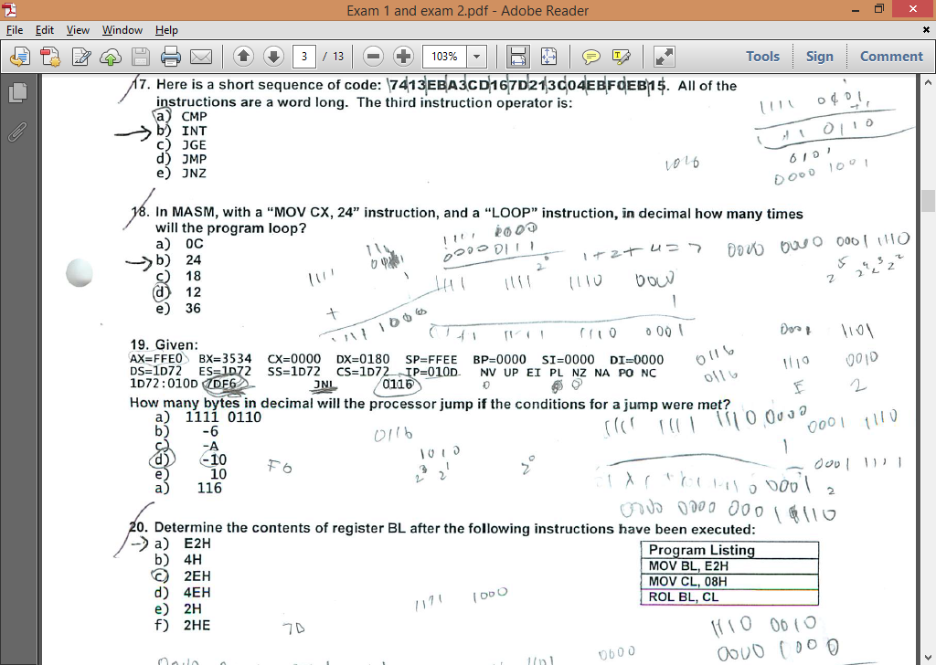

How many bytes in decimal will the processor jump if the conditions for a jump were met?

* 1. 10

1. Determine the contents of the register BL after the following instructions have been executed: 
   1. E2H
2. The ASCII codes for space, space, carriage return, line feed, end of string in hex are:
   1. 20, 20, 0D, 0A, 24
3. AND’ing 10H and 2FH will result in which of the following?
   1. 0
4. A “NOP” instruction in a program will
   1. Perform a No Operation
5. Given:

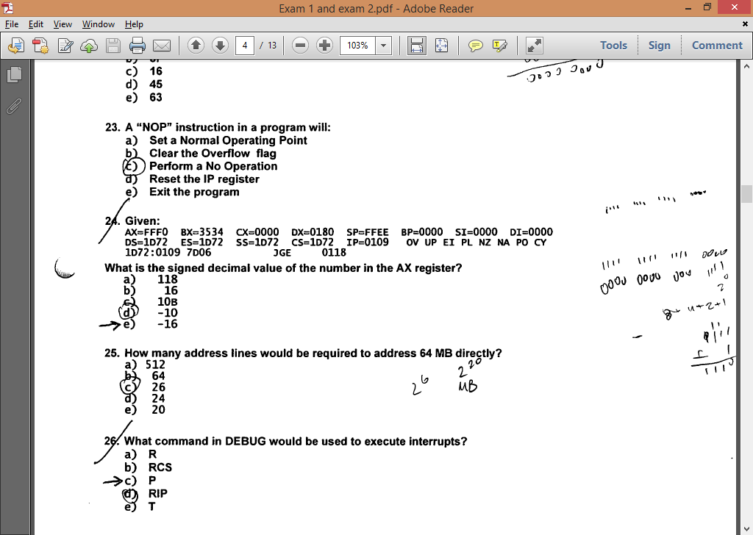

What is the signed decimal value of the number in the AX register?

* 1. -16

1. How many address lines would be required to address 64 MB directly?
   1. 26
2. What command in debug would be used to execute interrupts?
   1. P
3. What high level language is the propeller programmed in?
   1. Spin
4. Which of the following DOS debug instructions would be used to change the IP register to 010C?
   1. RIP
5. The acronym PWM used in Parallax Propeller and MicroChip PIC18, is defined as:
   1. Pulse width modulation
6. Which command would you use to execute another core in the propeller microcontroller?
   1. Cognew
7. Given:

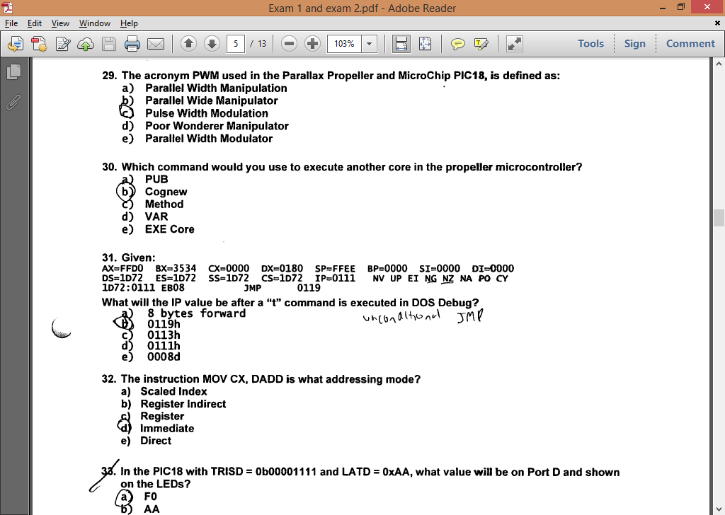

What will the IP value be after the “t” command is executed in DOS debug?

* 1. 0119h

1. The instruction MOV CD, DADD is what addressing mode?
   1. Immediate
2. How many byte in decimal will the processor jump if the conditions for a jump are met?
   1. 24
3. In the Propeller microcontroller, the command “dira[4..9] := %111111” would cause the processor to do which of the following?
   1. Sets the Propeller pins P4 through P9 as output pins
4. What are the contents of DX after this program has been run: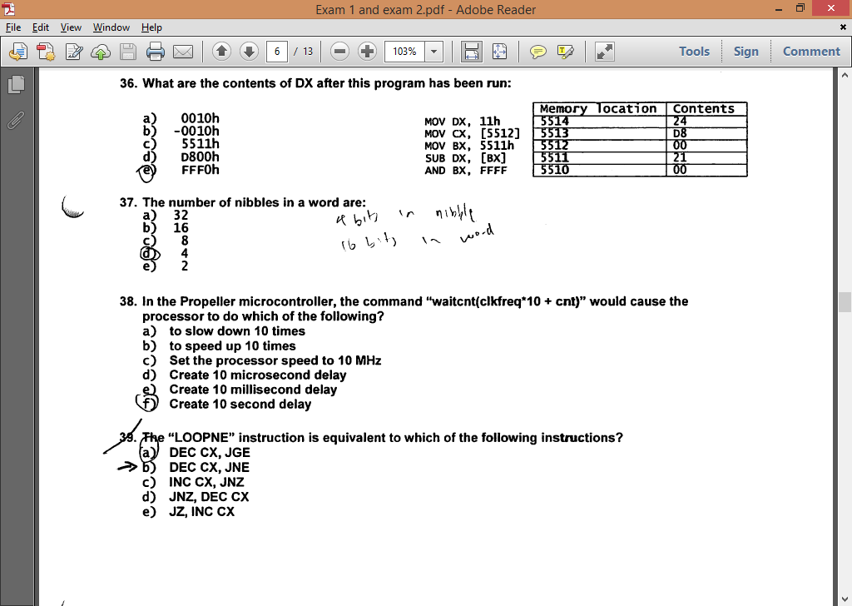
   1. FFF0h.
5. The number of nibbles in a word are:
   1. 4

What are the TTL logic level voltages for a logic 0 and logic 1?

0V to +5V

What is 152.875 converted to double precision fp?

40 63 06 00 00 00 00

What is 152.1875 converted to single precision fp?

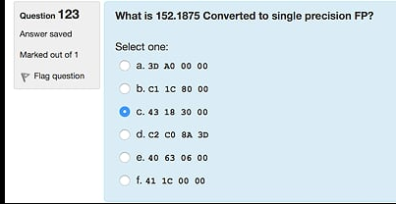

1. In the Propeller microcontroller, the command “waitcnt(clkfreq*10 + cnt)” would cause the processor to do which of the following?
   1. Create 10 second delay
2. The “LOOPNE” instruction is equivalent to which of the following instructions?
   1. DEC CX JNE
3. Given

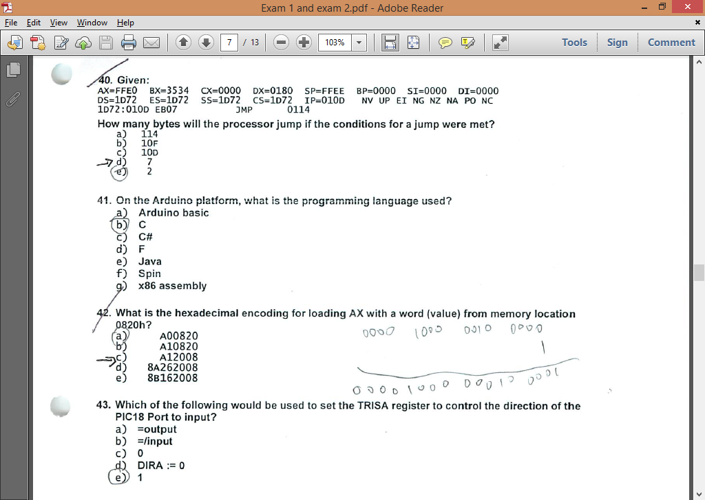

How many bytes will the processor jump if the conditions for a jump were met?

* 1. 7

1. On the Arduino platform, what is the programming language used?
   1. C
2. What is the hexadecimal encoding for loading AX with a word (value) from memory location 0820h?
   1. A12008
3. Which of the following would be used to set the TRISA register to control the direction of PIC18 Port to input?
   1. 1
4. The acronym ADC in microcontrollers stands for which of the following?
   1. Analog to Digital converter
5. In adding 5+5 through a 4 bit integer unit. The state of the 0F and CF flags after the add instruction would be:
   1. 0F = 1, CF = 0

Compare and contrast the Harvard architecture with the von Neumann

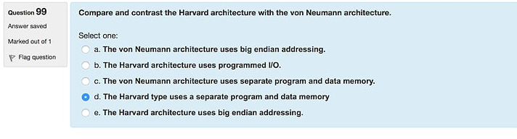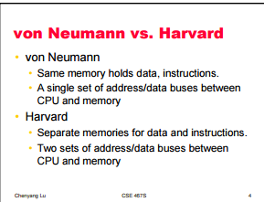

# S2010 MT2

1. How many bit(s) is/are required to represent a range of decimal numbers from0 to 127?
   1. **7**
2. If CX is 0003, what will CX be after a “LOOP” instruction?
   1. **0002**
3. IN the Propeller microcontroller, the command “waitcnt(clkfreq*5 + cnt)” would cause the processor to do which of the following?
   1. **A 5 second delay**
4. What is the number 1011.01012 in decimal?
   1. **11.31**
5. This section of memory represents a stack. What type of program is this?

BEEF : FFD0 00 00 00 00 00 00 00 00-00 00 00 00 00 00 00 00

BEEF : FFE0 00 01 02 03 04 05 06 07-08 09 0A 0B 0C 0D 0E 0F

BEEF : FFF0 11 22 33 44 55 66 77 88-99 AA BB CC DD EE FF

* 1. **COM program**

1. With a POPA instruction, what will be the order of the accumulator, base, count, and data registers restored from the stack?
   1. **BDCA**
2. Determine the contents of register BL after the following instruction have been executed:
   1. **2EH**
3. What Hex values must be sent to address the key pad rows on the PPE board?
   1. **1, 2, 4, 8**
4. What is the number 32.437510 in binary?
   1. **100000.01110**
5. In MASM, with a “MOV CX, 18h” instruction, and a “LOOP” instruction, in decimal how many times will the program loop?
   1. **24**
6. The acronym PWM used for motor control, is defined as which of the following?
   1. **Pulse Width Modulation**
7. Given the short code, what is the value in AX after the program is run?
   1. **0500**
8. What flag(s) does the “LOOPNZ” instruction look at to determine whether to loop or not?
   1. **ZF**
9. How many nibbles are in double precision IEEE floating point format number?
   1. **16**
10. What type of program is this?

AX=0000 BX=0000 CX=0000 DX=0180 SP=FFEE BP=0000 SI=0000 DI=0000

DS=1476 ES=1576 SS=1376 CS=1D72 IP=0015 NV UP EI PL NZ NA PO NC

1376:0015 0100 ADD [BI + SI], AL DS : 0000=CD

* 1. **EXE**

1. If the SP is F00F, what is the SP value after a “PUSH CX” instruction?
   1. **F00D**
2. In the PIC18 with TRISD = 0b00001111 and LATD = 0xAA, what value will be on Port D and shown on the LEDs?
   1. **A0**
3. What is the numeric sequence of the key pad columns on the PPE board?
   1. **37, 2F, 1F**
4. What is –130 decimal in 2’s complement (8bits)?
   1. **01111110**
5. Which of the following is a valid x86 command for multiplying a number?
   1. **MUL BX**
6. The number of bits in single precision IEEE floating point format are:
   1. **32**
7. You are trying to rebuild a HELLO project program in MASM and you get the following error:

“LINK : warning L4021: no stack segment”.

What would be the reason for such an error?

* 1. **No project template for COM was selected**

1. A “pull down” resistor is used in digital circuits to do what?
   1. **To keep the signal line “tied” low until the line is active (goes high)**
2. A “POP” instruction:
   1. **increments the SP**
3. AND’ing 10H and 2FH will result in which of the following?
   1. **0**
4. In the Propeller microcontroller, the command “dira[4..9] := %111111” would cause the processor to do which of the following?
   1. **Sets the Propeller pins P4 through P9 as output pins**
5. What commands in MASM-CodeView would be used to step through a program line by line?
   1. **T (F8)**
6. If the SP is F00F, what will the SP value be after a “POP SP” instruction?
   1. **F011**
7. On the PPE board, what number(s) on the key pad is(are) pressed for an output port value of 08h and an input port value of 2Fh?
   1. **0**
8. In the Propeller microcontroller, the term “Method” is(are) which of the following?
   1. **A block of executable commands that has variables, can receive parameters, and returns a value.**
9. Using MASM, which of the following will cause a program with a LOOP instruction to loop 48 times in decimal?
   1. **MOV CX, 30H or MOV CX, 48**
10. A “pull up” resistor is used in digital circuits to do what?
    1. **To keep the signal “tied” high until the line is active (goes low)**
11. With a PUSHA instruction, what will be the order of the register (registers A ~ D) contents on the stack?
    1. ACDB
12. The LOOPNE instruction performs which of the following?
    1. Decrements CX, tests the ZF flag, if it is not zero jumps to address specified.
13. What must the value be and in what register, prior to executing a LOOPNE instruction, to discontinue looping?
    1. CX =1
14. With a POPA instruction, what will be the order of the registers (registers A~ D) restored from stack?
    1. BDCA
15. What flags does the “LOOPNZ” instruction look at to determine whether to look or not?
    1. ZF
16. If the SP is F00F, what is the SP value after a “POP BX” instruction:
    1. F011
17. If CX is 0001, what will CX be after a “LOOPNZ” instruction:
    1. 0000
18. -11.25 in decimal converted to binary would be:
    1. -1011.0100
19. What is 31.4375 in binary?
    1. 011111.0111
20. Using debug which command should be used to change the flag setting?
    1. RF
21. What is 14.4375 in binary?
    1. 001110.01110

EEE 174 Midterm Study Guide

# S2010 MT 1

1. Int 21h, Function 09h requires three things set up before calling in order to correctly print a string, Hello_msg. They are:
   1. **DS = SEG Hello_msg, DX=OFFSET Hello_msg, Hello_msg terminated with 36**
2. Moore’s Law has accurately predicted the growth rate in the number of transistors per die for the last 40 years. What is the rate?
   1. **Doubling every 18 – 24 months**
3. Given:

AX=0353 BX=0534 CX=0000 DX=0180 SP=FFEE BP=0000 SI=0000 DI=0000

DS=1D72 ES=1D72 SS=1D72 CS=1D72 IP=0109 OV UP EI PL NZ NA PO CY

1D72:0109 7D06 JNL 0118

What will the IP value be after a “t” command is executed in DOS Debug?

* 1. **010B**

1. A “NOP” instruction will:
   1. **Perform a No OPeration**
2. Given:

AX=F247 BX=0000 CX=0000 DX=0000 SP=FFEE BP=0000 SI=0000 DI=0000

DS=1D72 ES=1D72 SS=1D72 CS=1D72 IP=0106 NV UP EI NG NZ NA PE NC

1D72:0106 EB0F JMP 0118

What will the IP value be after a “t” command is executed in DOS Debug?

* 1. **0118h**

1. In x86 architecture, BIU stands for which of the following?
   1. **Bus Interface Unit**
2. 7. Determine the contents of register BL after the following instructions have been executed:
   1. **2EH**
3. 8. The number of bytes in a double word are:
   1. **4**
4. In x86 architecture, ALU stands for which of the following?
   1. **Arithmetic Logic Unit**
5. The “LOOPNE” instruction is equivalent to which of the following instructions?
   1. **DEC CX, JNE**
6. The instruction MOV CX, DADD is what addressing mode?
   1. **Immediate**
7. Here is a short sequence of code: 7413EBA3CD167D213C04EBF0EB15. All of the instructions are a word long. The third instruction operator is:
   1. **INT**
8. Which of the following DOS Debug instructions would set a break point at memory location 010C?
   1. **G = 100 10C**
9. How many bytes are there in this short sequence of code? B400CD164CCD21
   1. **7**

**11.** How many bytes are there in this short sequence of code? B400CD16CD20

**a.** 6

1. How many address lines would be required to address 128 MB directly?
   1. **27**
2. What are the contents of CX after this program has been run:
   1. **D800h**
3. 1010 0110 in 2’s complement equals____ in base 10.
   1. **-90**
4. What is the hexadecimal encoding for adding AX with BX and storing the result in AX?
   1. **01D8**
5. What is 11.437510 in binary?
   1. **001011.01110**
6. If CX is 0000 what will CX be after a “LOOP” instruction?
   1. **FFFF**
7. Given:

AX=FFE0 BX=3534 CX=0000 DX=0180 SP=FFEE BP=0000 SI=0000 DI=0000

DS=1D72 ES=1D72 SS=1D72 CS=1D72 IP=010E OV UP EI PL NZ NA PO NC

1D72:010F 7D08 JGE 0115

How many bytes will the processor jump if the conditions for a jump were met?

* 1. **8**

1. What command in DEBUG would be used to execute interrupts?
   1. **P**
2. What is the advantage of C Language over Assembly Language?
   1. **C is transportable to other microprocessor architectures**
3. In adding 5+5 through a 4 but integer unit. The state of the OF and CF flags after the add instruction would be:
   1. **OF = 1, CF = 0**
4. In MASM, with a “MOV CX, 24h” instruction, and a “LOOP” instruction, in decimal how many times will the program loop?
   1. **36**
5. Given:

AX=0353 BX=3534 CX=0000 DX=0180 SP=FFEE BP=0000 SI=0000 DI=0000

DS=1D72 ES=1D72 SS=1D72 CS=1D72 IP=010D NV UP EI PL NZ NA PO NC

1D72:010D 7DF6 JNL 0116

* 1. **-10**

1. AND’ing 1FH and 20H will result in which of the following?
   1. **0**
2. Given:

13A7:0110 CD 20 32 20 54 48 39 73-20 69 73 20 74 68 65 20

13A7:0120 66 69 72 73 74 20 4D 69-64 74 65 72 6D 0D 24 D9

13A7:0130 00 C6 00 00 00 00 00 00-00 00 00 00 00 00 00 00

An input buffer is at memory location 0115, what is the size of the buffer in decimal?

* 1. **72**

1. A microprocessor with a 31-bit address bus could access how much memory?
   1. **2 GB**
2. For the instruction sequence below, determine the contents of the register AL after this program is executed:
   1. **51H**
3. Given:

AX=FF00 BX=3534 CX=0000 DX=0180 SP=FFEE BP=0000 SI=0000 DI=0000

DS=1D72 ES=1D72 SS=1D72 CS=1D72 IP=0109 OV UP EI PL NZ NA PO CY

1D72:0109 7D06 JNL 0118

What is the signed decimal value of the number in the AX register?

* 1. **-256**

1. The ASCII codes for space, space, carriage return, line feed, end of string in decimal are:
   1. **32, 32, 13, 10, 36**

**Spring 2012**

1. What is the advantage of assembly language over C language?
   1. The assembler creates much faster executable code
2. How many lines would be required to address 128 mb directly?
   1. 27
3. In the x86 lab part 3 Hello MASM program in the original code, what is the address of the byte used to start the number in the sequence “Hello World 0”?
   1. 020E
4. Given

W e l c o m e _ t o _ A s s e m

0B0E:0200 57 65 6C 63 6F 6D 65 20-74 6F 20 41 73 73 65 6D

0B0E:0210 62 6C 79 20 4C 61 6E 67-75 61 67 65 00 00 00 00

b l y _ L a n g u a g e

An Ascii message begins at memory location 0200, what is the message?

* 1. Welcome to Assembly Language

1. Which of the following DOS Debug instructions would be used to change the IP register to 0110?
   1. RIP
2. Moore’s law has accurately predicted the growth rate in the number of transistors per ide for the last 40 years. What is the rate?
   1. Doubling every 18 – 24 months
3. Which of the following DOS debug instructions would set a break point at memory location 010C?
   1. G = 1000 10C
4. AND’ing 1FH and 02H will result in which of the following?
   1. 02
5. If CX is 0000 what will CX be after a “LOOP” instruction?
   1. FFFF
6. The number of bits in a word are:
   1. 16
7. In x86 architecture, ALU stands for which of the following?
   1. Arithmetic Logical Unit
8. Given:



What will the IP value be after a “t” command is executed in DOS DEBUG?

* 1. 010B

1. What is the number 1010.01012 in decimal?
   1. 10.31
2. How many cores does the propeller microcontroller have?
   1. 8
3. What is the hexadecimal encoding for “JGE” for a jump back 12 bytes?
   1. 7DF2
4. What command in debug would be used to step through a program line by line?
   1. T
5. Here is a short sequence of code: 74 13 EB A3 CD 16 7D 21 3C 04 EB F0 EB 15. All of the instructions are a word long The third instruction operator is:
   1. INT
6. In MASM, with a “MOV CX, 24” instruction, and a “LOOP” instruction, in decimal how many times will the program loop?
   1. 24
7. Given:



How many bytes in decimal will the processor jump if the conditions for a jump were met?

* 1. 10

1. Determine the contents of the register BL after the following instructions have been executed: 
   1. E2H
2. The ASCII codes for space, space, carriage return, line feed, end of string in decimal are:
   1. 20, 20, 0D, 0A, 24
3. AND’ing 10H and 2FH will result in which of the following?
   1. 0
4. A “NOP” instruction in a program will
   1. Perform a No Operation
5. Given:



What is the signed decimal value of the number in the AX register?

* 1. -16

1. How many address lines would be required to address 64 MB directly?
   1. 26
2. What command in debug would be used to execute interrupts?
   1. P
3. What high level language is the propeller programmed in?
   1. Spin
4. Which of the following DOS debug instructions would be used to change the IP register to 010C?
   1. RIP
5. The acronym PWM used in Parallax Propeller and MicroChip PIC18, is defined as:
   1. Pulse width modulation
6. Which command would you use to execute another core in the propeller microcontroller?
   1. Cognew
7. Given:



What will the IP value be after the “t” command is executed in DOS debug?

* 1. 0119h

1. The instruction MOV CD, DADD is what addressing mode?
   1. Immediate
2. How many byte in decimal will the processor jump if the conditions for a jump are met?
   1. 24
3. In the Propeller microcontroller, the command “dira[4..9] := %111111” would cause the processor to do which of the following?
   1. Sets the Propeller pins P4 through P9 as output pins
4. What are the contents of DX after this program has been run:
   1. FFF0h.
5. The number of nibbles in a word are:
   1. 4
6. In the Propeller microcontroller, the command “waitcnt(clkfreq*10 + cnt)” would cause the processor to do which of the following?
   1. Create 10 second delay
7. The “PPE board E” instruction is equivalent to which of the following instructions?
   1. DEC CX JNE
8. Given



How many bytes will the processor jump if the conditions for a jump were met?

* 1. 7

1. On the Arduino platform, what is the programming language used?
   1. C
2. What is the hexadecimal encoding for loading AX with a word (value) from memory location 0820h?
   1. A12008
3. Which of the following would be used to set the TRISA register to control the direction of PIC18 Port to input?
   1. 1
4. The acronym ADC in microcontrollers stands for which of the following?
   1. Analog to Digital converter
5. In adding 5+5 through a 4 bit integer unit. The state of the 0F and CF flags after the add instruction would be:
   1. 0F = 1, CF = 0

# S2010 MT2

1. How many bit(s) is/are required to represent a range of decimal numbers from0 to 127?
   1. **7**
2. If CX is 0003, what will CX be after a “LOOP” instruction?
   1. **0002**
3. IN the Propeller microcontroller, the command “waitcnt(clkfreq*5 + cnt)” would cause the processor to do which of the following?
   1. **A 5 second delay**
4. What is the number 1011.01012 in decimal?
   1. **11.31**
5. This section of memory represents a stack. What type of program is this?

BEEF : FFD0 00 00 00 00 00 00 00 00-00 00 00 00 00 00 00 00

BEEF : FFE0 00 01 02 03 04 05 06 07-08 09 0A 0B 0C 0D 0E 0F

BEEF : FFF0 11 22 33 44 55 66 77 88-99 AA BB CC DD EE FF

* 1. **COM program**

1. With a POPA instruction, what will be the order of the accumulator, base, count, and data registers restored from the stack?
   1. **BDCA**
2. Determine the contents of register BL after the following instruction have been executed:
   1. **2EH**
3. What Hex values must be sent to address the key pad rows on the PPE board?
   1. **1, 2, 4, 8**
4. What is the number 32.437510 in binary?
   1. **100000.01110**
5. In MASM, with a “MOV CX, 18h” instruction, and a “LOOP” instruction, in decimal how many times will the program loop?
   1. **24**
6. The acronym PWM used for motor control, is defined as which of the following?
   1. **Pulse Width Modulation**
7. In the PIC18 with TRISD = 0b01111111, what is the configuration of the Port D?
   1. **Bit 7 of port D is set to output**
8. Given the short code, what is the value in AX after the program is run?
   1. **0500**
9. What flag(s) does the “LOOPNZ” instruction look at to determine whether to loop or not?
   1. **ZF**
10. How many nibbles are in double precision IEEE floating point format number?
    1. **16**
11. What type of program is this?

AX=0000 BX=0000 CX=0000 DX=0180 SP=FFEE BP=0000 SI=0000 DI=0000

DS=1476 ES=1576 SS=1376 CS=1D72 IP=0015 NV UP EI PL NZ NA PO NC

1376:0015 0100 ADD [BI + SI], AL DS : 0000=CD

* 1. **EXE**

1. If the SP is F00F, what is the SP value after a “PUSH CX” instruction?
   1. **F00D**
2. In the PIC18 with TRISD = 0b00001111 and LATD = 0xAA, what value will be on Port D and shown on the LEDs?
   1. **A0**
3. What is the numeric sequence of the key pad columns on the PPE board?
   1. **37, 2F, 1F**
4. What is –130 decimal in 2’s complement (8bits)?
   1. **01111110**
5. Which of the following is a valid x86 command for multiplying a number?
   1. **MUL BX**
6. The number of bits in single precision IEEE floating point format are:
   1. **32**
7. You are trying to rebuild a HELLO project program in MASM and you get the following error:

“LINK : warning L4021: no stack segment”.

What would be the reason for such an error?

* 1. **No project template for COM was selected**

1. A “pull down” resistor is used in digital circuits to do what?
   1. **To keep the signal line “tied” low until the line is active (goes high)**
2. A “POP” instruction:
   1. **increments the SP**
3. AND’ing 10H and 2FH will result in which of the following?
   1. **0**
4. In the Propeller microcontroller, the command “dira[4..9] := %111111” would cause the processor to do which of the following?
   1. **Sets the Propeller pins P4 through P9 as output pins**
5. What commands in MASM-CodeView would be used to step through a program line by line?
   1. **T (F8)**
6. If the SP is F00F, what will the SP value be after a “POP SP” instruction?
   1. **F011**
7. On the PPE board, what number(s) on the key pad is(are) pressed for an output port value of 08h and an input port value of 2Fh?
   1. **0**
8. In the Propeller microcontroller, the term “Method” is(are) which of the following?
   1. **A block of executable commands that has variables, can receive parameters, and returns a value.**
9. Using MASM, which of the following will cause a program with a LOOP instruction to loop 48 times in decimal?
   1. **MOV CX, 30H or MOV CX, 48**
10. A “pull up” resistor is used in digital circuits to do what?
    1. **To keep the signal “tied” high until the line is active (goes low)**

SECOND DOCUMENT

# S2010 MT 1

1. Int 21h, Function 09h requires three things set up before calling in order to correctly print a string, Hello_msg. They are:

**DS = SEG Hello_msg, DX=OFFSET Hello_msg, Hello_msg terminated with 36**

2. Moore’s Law has accurately predicted the growth rate in the number of transistors per die for the last 40 years. What is the rate?

**Doubling every 18 – 24 months**

3. Given:

AX=0353 BX=0534 CX=0000 DX=0180 SP=FFEE BP=0000 SI=0000 DI=0000

DS=1D72 ES=1D72 SS=1D72 CS=1D72 IP=0109 OV UP EI PL NZ NA PO CY

1D72:0109 7D06 JNL 0118

What will the IP value be after a “t” command is executed in DOS Debu range of decimal numbers range of decimal numbers g?

**010B**

4. A “NOP” instruction will:

**Perform a No OPeration**

5. Given:

AX=F247 BX=0000 CX=0000 DX=0000 SP=FFEE BP=0000 SI=0000 DI=0000

DS=1D72 ES=1D72 SS=1D72 CS=1D72 IP=0106 NV UP EI NG NZ NA PE NC

1D72:0106 EB0F JMP 0118

What will the IP value be after a “t” command is executed in DOS Debug?

**0118h**

6. In x86 architecture, BIU stands for which of the following?

**Bus Interface Unit**

7. Determine the contents of register BL after the following instructions have been executed:

**2EH**

8. The number of bytes in a double word are:

**4**

9. In x86 architecture, ALU stands for which of the following?

**Arithmetic Logic Unit**

10. The “LOOPNE” instruction is equivalent to which of the following instructions?

**DEC CX, JNE**

11. The instruction MOV CX, DADD is what addressing mode?

**Immediate**

12. Here is a short sequence of code: 7413EBA3CD167D213C04EBF0EB15. All of the instructions are a word long. The third instruction operator is:

**INT 16**

13. Which of the following DOS Debug instructions would set a break point at memory location 010C?

**G = 100 10C**

14. How many bytes are there in this short sequence of code? B400CD164CCD21

**7**

15. How many address lines would be required to address 128 MB directly?

**27**

16. What are the contents of CX after this program has been run:

**D800h**

17. 1010 0110 in 2’s complement equals____ in base 10.

**-90**

18. What is the hexadecimal encoding for adding AX with BX and storing the result in AX?

**01D8**

19. What is 11.437510 in binary?

**001011.01110**

20. If CX is 0000 what will CX be after a “LOOP” instruction?

**FFFF**

22. Given:

AX=FFE0 BX=3534 CX=0000 DX=0180 SP=FFEE BP=0000 SI=0000 DI=0000

DS=1D72 ES=1D72 SS=1D72 CS=1D72 IP=010E OV UP EI PL NZ NA PO NC

1D72:010F 7D08 JGE 0115

How many bytes will the processor jump if the conditions for a jump were met?

**8**

23. What command in DEBUG would be used to execute interrupts?

**P**

24. What is the advantage of C Language over Assembly Language?

**C is transportable to other microprocessor architectures**

25. In adding 5+5 through a 4 but integer unit. The state of the OF and CF flags after the add instruction would be:

**OF = 1, CF = 0**

26. In MASM, with a “MOV CX, 24” instruction, and a “LOOP” instruction, in decimal how many times will the program loop?

**36**

27. Given:

AX=0353 BX=3534 CX=0000 DX=0180 SP=FFEE BP=0000 SI=0000 DI=0000

DS=1D72 ES=1D72 SS=1D72 CS=1D72 IP=010D NV UP EI PL NZ NA PO NC

1D72:010D 7DF6 JNL 0116

**-10**

28. AND’ing 1FH and 20H will result in which of the following?

**0**

29. Given:

13A7:0110 CD 20 32 20 54 48 39 73-20 69 73 20 74 68 65 20

13A7:0120 66 69 72 73 74 20 4D 69-64 74 65 72 6D 0D 24 D9

13A7:0130 00 C6 00 00 00 00 00 00-00 00 00 00 00 00 00 00

An input buffer is at memory location 0115, what is the size of the buffer in decimal?

**72**

30. A microprocessor with a 31-bit address bus could access how much memory?

**2 GB**

31. For the instruction sequence below, determine the contents of the register AL after this program is executed:

**51H**

32. Given:

AX=FF00 BX=3534 CX=0000 DX=0180 SP=FFEE BP=0000 SI=0000 DI=0000

DS=1D72 ES=1D72 SS=1D72 CS=1D72 IP=0109 OV UP EI PL NZ NA PO CY

1D72:0109 7D06 JNL 0118

What is the signed decimal value of the number in the AX register?

**-256**

33. The ASCII codes for space, space, carriage return, line feed, end of string in decimal are:

**32, 32, 13, 10, 36**

# S2010 MT2

1. How many bit(s) is/are required to represent a range of decimal numbers from0 to 127?

**7**

2. If CX is 0003, what will CX be after a “LOOP” instruction?

**0002**

3. IN the Propeller microcontroller, the command “waitcnt(clkfreq*5 + cnt)” would cause the processor to do which of the following?

**A 5 second delay**

4. What is the number 1011.01012 in decimal?

**11.31**

5. This section of memory represents a stack. What type of program is this?

BEEF : FFD0 00 00 00 00 00 00 00 00-00 00 00 00 00 00 00 00

BEEF : FFE0 00 01 02 03 04 05 06 07-08 09 0A 0B 0C 0D 0E 0F

BEEF : FFF0 11 22 33 44 55 66 77 88-99 AA BB CC DD EE FF

**COM program**

6. With a POPA instruction, what will be the order of the accumulator, base, count, and data registers restored from the stack?

**BDCA**

7. Determine the contents of register BL after the following instruction have been executed:

**2EH**

8. What Hex values must be sent to address the key pad rows on the PPE board?

**1, 2, 4, 8**

9. What is the number 32.437510 in binary?

**100000.01110**

10. In MASM, with a “MOV CX, 18h” instruction, and a “LOOP” instruction, in decimal how many times will the program loop?

**24**

11. The acronym PWM used for motor control, is defined as which of the following?

**Pulse Width Modulation**

12. In the PIC18 with TRISD = 0b01111111, what is the configuration of the Port D?

**Bit 7 of port D is set to output**

13. Given the short code, what is the value in AX after the program is run?

**0500**

14. What flag(s) does the “LOOPNZ” instruction look at to determine whether to loop or not?

**ZF**

15. How many nibbles are in double precision IEEE floating point format number?

**16**

17. What type of program is this?

AX=0000 BX=0000 CX=0000 DX=0180 SP=FFEE BP=0000 SI=0000 DI=0000

DS=1476 ES=1576 SS=1376 CS=1D72 IP=0015 NV UP EI PL NZ NA PO NC

1376:0015 0100 ADD [BI + SI], AL DS : 0000=CD

**EXE**

18. If the SP is F00F, what is the SP value after a “PUSH CX” instruction?

**F00D**

19. In the PIC18 with TRISD = 0b00001111 and LATD = 0xAA, what value will be on Port D and shown on the LEDs?

**A0**

20. What is the numeric sequence of the key pad columns on the PPE board?

**37, 2F, 1F**

21. What is –130 decimal in 2’s complement (8bits)?

**01111110**

22. Which of the following is a valid x86 command for multiplying a number?

**MUL BX**

23. The number of bits in single precision IEEE floating point format are:

**32**

24. You are trying to rebuild a HELLO project program in MASM and you get the following error:

“LINK : warning L4021: no stack segment”.

What would be the reason for such an error?

**No project template for COM was selected**

25. A “pull down” resistor is used in digital circuits to do what?

**To keep the signal line “tied” low until the line is active (goes high)**

26. A “POP” instruction:

**increments the SP**

27. AND’ing 10H and 2FH will result in which of the following?

**0**

28. In the Propeller microcontroller, the command “dira[4..9] := %111111” would cause the processor to do which of the following?

**Sets the Propeller pins P4 through P9 as output pins**

29. What commands in MASM-CodeView would be used to step through a program line by line?

**T (F8)**

30. If the SP is F00F, what will the SP value be after a “POP SP” instruction?

**F011**

31. On the PPE board, what number(s) on the key pad is(are) pressed for an output port value of 08h and an input port value of 2Fh?

**0**

32. In the Propeller microcontroller, the term “Method” is(are) which of the following?

**A block of executable commands that has variables, can receive parameters, and returns a value.**

33. Using MASM, which of the following will cause a program with a LOOP instruction to loop 48 times in decimal?

**MOV CX, 30H or MOV CX, 48**

34. A “pull up” resistor is used in digital circuits to do what?

**To keep the signal “tied” high until the line is active (goes low)**

How many bit(s) is/are required to represent a range of decimal numbers from 0 to 9?

1. 4

A “POP” instruction:

1. increments the Stack Pointer, SP

The instruction MOV CX, SI is what addressing mode?

1. Register Addressing - direct

The instruction MOV CX, [SI] is what addressing mode?

1. Register Indirect

Which of the following will cause a program with a LOOP instruction to loop 48 times (decimal)”

1. ***CX = 30h***

A “PUSH” instruction:

1. Decrements the SP/increments the IP

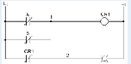

The Ladder Logic diagram would represent which of the following?

1. NOR

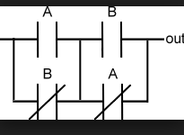

XNOR

If you want to use a INT software interrupt function to print a string out to the screen, what is the function code, start pointer, termination character, and interrupt you need to use?

Select one:

1. ah = 09h, ds:dx, “$”, 21h

You are trying to rebuild a HELLO project program in MASM and you get the following error: “LINK: fatal error L1089: HELLO.lrf: cannot open response file”.

What would be the reason for such an error?

Select one:

1. No source file is identified (no.asm file)

The instruction MOV SI, 4DAD is what addressing mode?

Select one:

1. Immediate

How many nibble are in double precision IEEE floating point format numbers (64bit)?

Select one:

1. 16

What flag(s) does the “LOOPNE” instruction look at to determine whether to loop or not?

1. ZF

What is the numeric sequence of the key pad columns on the PPE board?

Select one:

1. 37,2F,1F

18 hexadecimal would be what value in decimal?

1. 24

In the PIC 18 with TRISD = 0b01000000, what is the configuration of the Port D?

Select one:

1. Bit 6 of port D is set to input

In the PIC 18 with TRISD = 0b10000000, what is the configuration of the Port D?

Select one:

1. Bit 7 of port D is set to input

What register(s) does the “LOOPNE” instruction look at to determine how many times to loop?

Select one:

1. CX

If CX is 0003, what will CX be after a “LOOPNZ” instruction?

Select one:

1. 0002

What type of program is this?



Select one:

1. EXE program

Determine the content of register BL after the following instruction have been executed:

a) E2H MOV BL, 2EH

MOV CL, 0100b

ROL BL, CL

OTHER

A “pull down” resistor is used in digital circuits to do what?

b) To keep the signal line “tied” low until the line is active (goes high)

A “pull up” resistor is used in digital circuits to do what?

c) To keep the signal “tied” high until the line is active (goes low)

Double precision IEEE FP standard uses _____ nibbles to represent data:

1. 16

How many bytes are in double precision IEEE floating point format numbers?

1. 8

You are trying to rebuild a Hello project program in MASM and you get the following error: “LINK : warning L4021: no stack segment”.

1. No project template for COM was selected

How many double words are in double IEEE floating point format numbers?

1. 16

In x86 architecture, BIU stands for which of the following?

1. Bus Interface Unit

Moore’s law has accurately predicted the growth rate in the number of transistors per die for the last 40 years. What is that rate?

b) Doubling every 18 – 24 months

NMI stands for what?

1. Non Maskable Interrupt – it means it cannot be blocked

The letters “NC” labeled on relays and PLCs means which of the following?

1. Normally Closed

The number of bits in single precision IEEE floating point format are:

1. 32

The number of bytes in extended precision IEEE floating point format are:

b) 10

The Ladder Logic diagram would represent which of the following?

1. XOR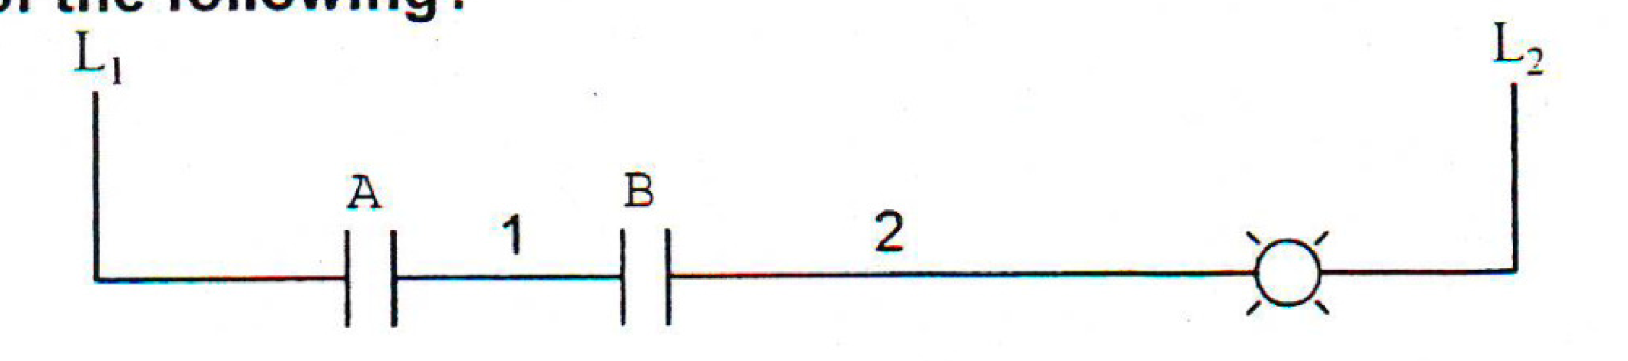
2. OR
3. NAND
4. AND
5. OPEN CIRCUIT

The Ladder Logic diagram would represent which of the following?

1. XOR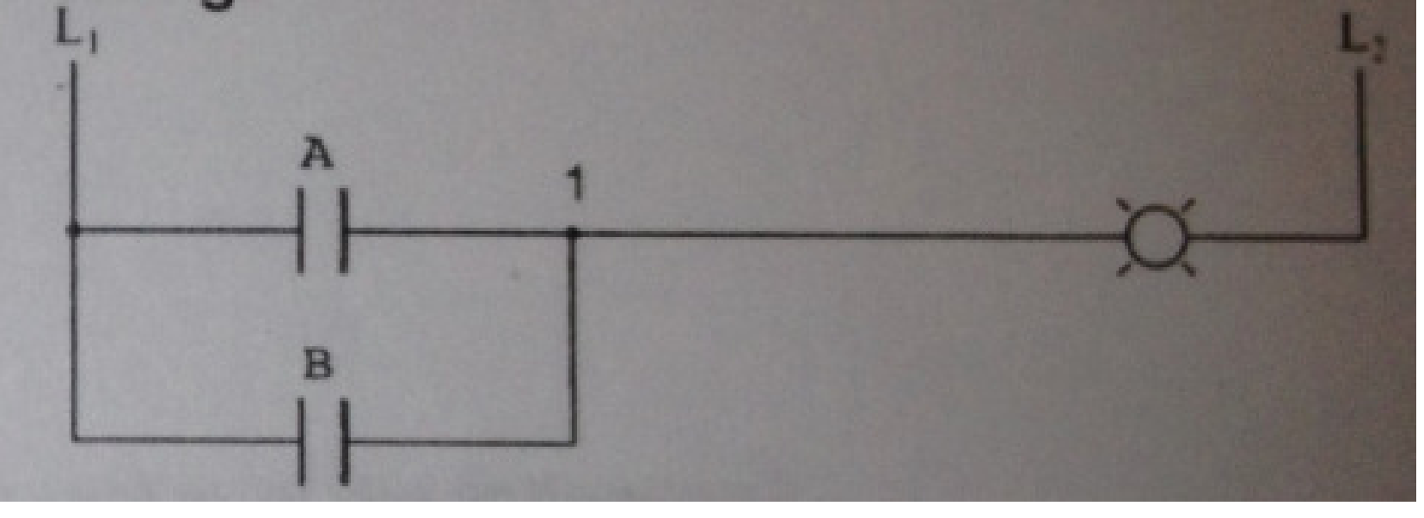
2. OR
3. NAND
4. AND
5. OPEN CIRCUIT

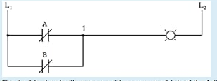

NOR

What is the decimal value of C1 1C 00 00 in IEEE single precision FP format?

1. -9.75

What is the advantage of Assembly Language over C Language?

a) The assembler creates much faster executable code

What is(are) the advantage(s) of C Language over Assembly Language?

1. C is transportable to other microprocessor architectures

What is the decimal value of C5 5A 57 00 in IEEE single precision FP format?

1. -3493.4375

PPE

On the PPE board, what number(s) on the key pad is(are) processed for an output port value of 08h and an input port value of 2Fh?

1. 0

On the PPE board, what number(s) on the key pad is(are) pressed for an output port value of 01h and an input port value of 1Fh?

1. 3

On the PPE board, what number(s) on the key pad is(are) pressed for an output port value of 02h and an input port value of 2fh?

1. 5

On the PPE board, what number(s) on the key pad is(are) pressed for an output port of 04h and an input port value of 2Fh?

1. 8

What Hex values must be sent to address the key pad rows on the PPE boad?

1. 1,2,4,8

On the raspberry pi platform, what is the programming language used?

Various open source languages

What is the numeric sequence of the key pad columns on the PPE board?

1. 37, 2F, 1F

What is the numeric sequence to address the key pad rows on the PPE board used in the lab?

1. 1,2,4,8

Arduino

Which of the following instruction would be used to set the LED to light on the Arduino Platform?

1. LED = 1

On the Arduino platform, what is the programming language used?

1. C

Microchip PICKIT

How many bits does the PIC 18 microcontroller used in the PICit 3 Debug Express have?

1. 16

In the PIC18 with TRISD = 0b10000000, what is the configuration of the Port D?

1. Bit 7 of port D is set to input

In the PIC18 with TRISD = 0b00001111 and LATD = 0xAA, what value will be on Port D and shown on the LEDs?

1. A0

In the PIC18 with TRISD = 0b11110000 and LATD = 0xAA, what value will be on Port D and shown on the LEDs?

1. 0A

In the PIC18 with TRISD = 0b01111111, what is the configuration of the Port D?

1. Bit 7 of port D is set to output

Which of the following would be used to set the TRISA register to control the direction of the PIC18 Port to input?

1. 1

A “POPstruction:

Increments the SP

With a “POPAX” instruction, what will the order of the accumulator, base, count, and data registers restored from the stack?

ax

DAS used for BCD operation stand for which of the following?

Decimal adjust for subtraction

What is -1011.0101 in decimal?

-11.31

what is -32.75 in binary?

-100000.11000

what command in debug would be used to change the IP value?

RIP

What is -130 decimal in 2’s complement (8 bits)?

01111110

what is the decimal value of C5 5A 57 00 in IEEE single precision FP format?

-3493.4375

What is -34 decimal in 2’s complement?

1101 1110

EEE 174 Midterm Study Guide

# S2010 MT 1

1. Int 21h, Function 09h requires three things set up before calling in order to correctly print a string, Hello_msg. They are:
   1. **DS = SEG Hello_msg, DX=OFFSET Hello_msg, Hello_msg terminated with 36**
2. Moore’s Law has accurately predicted the growth rate in the number of transistors per die for the last 40 years. What is the rate?
   1. **Doubling every 18 – 24 months**
3. Given:

AX=0353 BX=0534 CX=0000 DX=0180 SP=FFEE BP=0000 SI=0000 DI=0000

DS=1D72 ES=1D72 SS=1D72 CS=1D72 IP=0109 OV UP EI PL NZ NA PO CY

1D72:0109 7D06 JNL 0118

What will the IP value be after a “t” command is executed in DOS Debug?

* 1. **010B**

1. A “NOP” instruction will:
   1. **Perform a No OPeration**
2. Given:

AX=F247 BX=0000 CX=0000 DX=0000 SP=FFEE BP=0000 SI=0000 DI=0000

DS=1D72 ES=1D72 SS=1D72 CS=1D72 IP=0106 NV UP EI NG NZ NA PE NC

1D72:0106 EB0F JMP 0118

What will the IP value be after a “t” command is executed in DOS Debug?

* 1. **0118h**

1. In x86 architecture, BIU stands for which of the following?
   1. **Bus Interface Unit**
2. 7. Determine the contents of register BL after the following instructions have been executed:
   1. **2EH**
3. 8. The number of bytes in a double word are:
   1. **4**
4. In x86 architecture, ALU stands for which of the following?
   1. **Arithmetic Logic Unit**
5. The “LOOPNE” instruction is equivalent to which of the following instructions?
   1. **DEC CX, JNE**
6. The instruction MOV CX, DADD is what addressing mode?
   1. **Immediate**
7. Here is a short sequence of code: 7413EBA3CD167D213C04EBF0EB15. All of the instructions are a word long. The third instruction operator is:
   1. **INT**
8. Which of the following DOS Debug instructions would set a break point at memory location 010C?
   1. **G = 100 10C**
9. How many bytes are there in this short sequence of code? B400CD164CCD21
   1. **7**
10. How many address lines would be required to address 128 MB directly?
    1. **27**
11. What are the contents of CX after this program has been run:
    1. **D800h**
12. 1010 0110 in 2’s complement equals____ in base 10.
    1. **-90**
13. What is the hexadecimal encoding for adding AX with BX and storing the result in AX?
    1. **01D8**
14. What is 11.437510 in binary?
    1. **001011.01110**
15. If CX is 0000 what will CX be after a “LOOP” instruction?
    1. **FFFF**
16. Given:

AX=FFE0 BX=3534 CX=0000 DX=0180 SP=FFEE BP=0000 SI=0000 DI=0000

DS=1D72 ES=1D72 SS=1D72 CS=1D72 IP=010E OV UP EI PL NZ NA PO NC

1D72:010F 7D08 JGE 0115

How many bytes will the processor jump if the conditions for a jump were met?

* 1. **8**

1. What command in DEBUG would be used to execute interrupts?
   1. **P**
2. What is the advantage of C Language over Assembly Language?
   1. **C is transportable to other microprocessor architectures**
3. In adding 5+5 through a 4 but integer unit. The state of the OF and CF flags after the add instruction would be:
   1. **OF = 1, CF = 0**
4. In MASM, with a “MOV CX, 36” instruction, and a “LOOP” instruction, in decimal how many times will the program loop?
   1. **36**
5. Given:

AX=0353 BX=3534 CX=0000 DX=0180 SP=FFEE BP=0000 SI=0000 DI=0000

DS=1D72 ES=1D72 SS=1D72 CS=1D72 IP=010D NV UP EI PL NZ NA PO NC

1D72:010D 7DF6 JNL 0116

* 1. **-10**

1. AND’ing 1FH and 20H will result in which of the following?
   1. **0**
2. Given:

13A7:0110 CD 20 32 20 54 48 39 73-20 69 73 20 74 68 65 20

13A7:0120 66 69 72 73 74 20 4D 69-64 74 65 72 6D 0D 24 D9

13A7:0130 00 C6 00 00 00 00 00 00-00 00 00 00 00 00 00 00

An input buffer is at memory location 0115, what is the size of the buffer in decimal?

* 1. **72**

An input buffer is at memory location 0114, what is the size of the buffer in decimal?

1. **84**
2. A microprocessor with a 31-bit address bus could access how much memory?
   1. **2 GB**
3. For the instruction sequence below, determine the contents of the register AL after this program is executed:
   1. **51H**
4. Given:

AX=FF00 BX=3534 CX=0000 DX=0180 SP=FFEE BP=0000 SI=0000 DI=0000

DS=1D72 ES=1D72 SS=1D72 CS=1D72 IP=0109 OV UP EI PL NZ NA PO CY

1D72:0109 7D06 JNL 0118

What is the signed decimal value of the number in the AX register?

* 1. **-256**

1. The ASCII codes for space, space, carriage return, line feed, end of string in decimal are:
   1. **32, 32, 13, 10, 36**

**Spring 2012**

1. What is the advantage of assembly language over C language?
   1. The assembler creates much faster executable code
2. How many lines would be required to address 128 mb directly?
   1. 27
3. In the x86 lab part 3 Hello MASM program in the original code, what is the address of the byte used to start the number in the sequence “Hello World 0”?
   1. 020E
4. Given

W e l c o m e _ t o _ A s s e m

0B0E:0200 57 65 6C 63 6F 6D 65 20-74 6F 20 41 73 73 65 6D

0B0E:0210 62 6C 79 20 4C 61 6E 67-75 61 67 65 00 00 00 00

b l y _ L a n g u a g e

An Ascii message begins at memory location 0200, what is the message?

* 1. Welcome to Assembly Language

1. Which of the following DOS Debug instructions would be used to change the IP register to 0110?
   1. RIP
2. Moore’s law has accurately predicted the growth rate in the number of transistors per ide for the last 40 years. What is the rate?
   1. Doubling every 18 – 24 months
3. Which of the following DOS debug instructions would set a break point at memory location 010C?
   1. G = 1000 10C
4. AND’ing 1FH and 02H will result in which of the following?
   1. 02
5. If CX is 0000 what will CX be after a “LOOP” instruction?
   1. FFFF
6. The number of bits in a word are:
   1. 16
7. The number of bits in a double word are:

32

1. In x86 architecture, ALU stands for which of the following?
   1. Arithmetic Logical Unit
2. Given:



What will the IP value be after a “t” command is executed in DOS DEBUG?

* 1. 010B

1. What is the number 1010.01012 in decimal?
   1. 10.31
2. How many cores does the propeller microcontroller have?
   1. 8
3. What is the hexadecimal encoding for “JGE” for a jump back 12 bytes?
   1. 7DF2
4. What command in debug would be used to step through a program line by line?
   1. T
5. Here is a short sequence of code: 74 13 EB A3 CD 16 7D 21 3C 04 EB F0 EB 15. All of the instructions are a word long The third instruction operator is:
   1. INT
6. In MASM, with a “MOV CX, 24” instruction, and a “LOOP” instruction, in decimal how many times will the program loop?
   1. 24
7. Given:



How many bytes in decimal will the processor jump if the conditions for a jump were met?

* 1. 10

1. Determine the contents of the register BL after the following instructions have been executed: 
   1. E2H
2. The ASCII codes for space, space, carriage return, line feed, end of string in decimal are:
   1. 20, 20, 0D, 0A, 24
3. AND’ing 10H and 2FH will result in which of the following?
   1. 0
4. A “NOP” instruction in a program will
   1. Perform a No Operation
5. Given:



What is the signed decimal value of the number in the AX register?

* 1. -16

1. How many address lines would be required to address 64 MB directly?
   1. 26
2. What command in debug would be used to execute interrupts?
   1. P
3. What high level language is the propeller programmed in?
   1. Spin
4. Which of the following DOS debug instructions would be used to change the IP register to 010C?
   1. RIP
5. The acronym PWM used in Parallax Propeller and MicroChip PIC18, is defined as:
   1. Pulse width modulation
6. Which command would you use to execute another core in the propeller microcontroller?
   1. Cognew
7. Given:



What will the IP value be after the “t” command is executed in DOS debug?

* 1. 0119h

1. The instruction MOV CD, DADD is what addressing mode?
   1. Immediate
2. In the PIC18 with TRISD = 0b00001111 and LATD = 0xAA, what value will be on Port D and shown on the LEDs?
   1. F0
3. How many byte in decimal will the processor jump if the conditions for a jump are met?
   1. 24
4. In the Propeller microcontroller, the command “dira[4..9] := %111111” would cause the processor to do which of the following?
   1. Sets the Propeller pins P4 through P9 as output pins
5. What are the contents of DX after this program has been run:
   1. FFF0h.
6. The number of nibbles in a word are:
   1. 4
7. In the Propeller microcontroller, the command “waitcnt(clkfreq*10 + cnt)” would cause the processor to do which of the following?
   1. Create 10 second delay
8. The “LOOPNE” instruction is equivalent to which of the following instructions?
   1. DEC CX JNE
9. Given



How many bytes will the processor jump if the conditions for a jump were met?

* 1. 7

1. On the Arduino platform, what is the programming language used?
   1. C
2. What is the hexadecimal encoding for loading AX with a word (value) from memory location 0820h?
   1. A12008
3. Which of the following would be used to set the TRISA register to control the direction of PIC18 Port to input?
   1. 1
4. The acronym ADC in microcontrollers stands for which of the following?
   1. Analog to Digital converter
5. In adding 5+5 through a 4 bit integer unit. The state of the 0F and CF flags after the add instruction would be:
   1. 0F = 1, CF = 0
6. What is the advantage of Assembly Language over C Language?
   1. **The Assembler creates much faster executable code**
7. How many address lines would be required to address 128 MB directly?
   1. **27**
8. In the x86 lab part Hello MASM program in the original code, what is the address of the byte used to start number in the sequence “Hello World 0”?
   1. **020E**
9. Given:

0B0E : 0200 57 65 6C 63 F 6D 65 20-74 6F 20 41 73 73 65 6D

0B0E: 0210 62 6C 79 20 4C 61 6E 67-75 61 67 65 00 00 00 00

An ASCII message begins at memory location 0200, what is the message?

* 1. **Welcome to Assembly Language**

1. Which of the following DOS Debug instructions would be used to change the IP register to 0110?
   1. **RIP**
2. Moore’s law has accurately predicted the growth rate in the number of transistors per die for the last 40 years. What is the rate?
   1. **Doubling every 18-24 months**
3. Which of the following DOS Debug instructions would set a break point at memory location 010C?
   1. **G = 100 10C**
4. AND’ing 1FH and 02H will result in which of the following?
   1. **02**
5. If CX is 0000 what will CX be after a “LOOP” instruction?
   1. **FFFF**
6. The number of bits in a word are:
   1. **16**
7. In x86 architecture, ALU stands for which of the following?
   1. **Arithmetic Logic Unit**
8. Given:

AX=0353 BX=0534 CX=0000 DX=0180 SP=FFEE BP=0000 SI=0000 DI=0000

DS=1D72 ES=1D72 SS=1D72 CS=1D72 IP=0109 0V UP EI PL NZ NA PO CY

1D72:0109 7D06 JGE 0118

What will the IP value be after a “t” command is executed in DOS Debug?

* 1. **010B**

1. What is the number, 1010.01012 in decimal?
   1. **10.31**
2. How many cores does the propeller microcontroller have?
   1. **8**
3. What is the hexadecimal encoding for “JGE” for a jump back 12 bytes?
   1. **7DF2**
4. What command in DEBUG would be used to step through a program line by line?
   1. **T**
5. Here is a short sequence of code: 74 13 EB A3 CD 16 7D 21 3C 04 EB F0 EB 15. All of the instructions are a word long. The third instruction operator is:
   1. **INT**
6. In MASM, with a “MOV CX, 24” instruction, and a “LOOP” instruction, in decimal how many times will the program loop?
   1. **24**
7. Given:

AX=FFE0 BX=3534 CX=0000 DX=0180 SP=FFEE BP=0000 SI=0000 DI=0000

DS=1D72 ES=1D72 SS=1D72 CS=1D72 IP=010D NV UP EI PL NZ NA PO NC

1D72:010D 7DF6 JNI 0116

How many bytes in decimal will the processor jump if the conditions for a jump were met?

* 1. **10**

1. Determine the contents of register BL after the following instructions have been executed:
   1. **E2H**
2. The ASCII codes for space, space, carriage return, line feed, end of string in decimal are:
   1. **32, 32, 13, 10, 36**
3. AND’ing 10H and 2FH will result in which of the following?
   1. **0**
4. A “NOP” instruction in a program will:
   1. **Perform a No Operation**
5. Given:

AX=FFF0 BX=3534 CX=0000 DX=0180 SP=FFEE BP=0000 SI=0000 DI=0000 DS=1D72 ES=1D72 SS=1D72 CS=1D72 IP=0109 OV UP EI PL NZ NA PO CY

ID72:0109 7D06 JGE 0118

What is the signed decimal value of the number in the AX register?

* + **-16**

1. How many address lines would be required to address 64 MB directly?
   * **26**
2. What command in DEBUG would be used to execute interrupts?
   * **P**
3. What high level language is the propeller programmed in?
   * **Spin**
4. Which of the following DOS Debug Instructions would be used to change the IP register to 010C?
   * **RIP**
5. The acronym PWM used in the Parallax Propeller and MicroChip PIC18, is defined as:
   * **Pulse Width Modulation**
6. Which command would you use to execute another core in the propeller microcontroller?
   * **Cognew**
7. Given:

AX=FFDO BX=3534 CX=0000 DX=0180 SP=FFEE BP=0000 SI=0000 DI=0000

DS=1D72 ES=1D72 SS=1D72 CS=1D72 IP=0111 NV UP EI NG NZ NA PO CY

1D72:0111 ED08 JMP 0119

What will the IP value be after a “t” command is executed in DOS Debug?

* + **0119h**

1. The instruction MOV CX, DADD is what addressing mode?
   * **Immediate**
2. In the PIC18 with TRISD = 0b00001111 and LATD = 0xAA, what value will be on Port D and shown on the LEDs?
   * **A0**
3. Given:

AX=FFE0 BX=3534 CX=0000 DX=0180 SP=FFEE BP=0000 SI=0000 DI=0000

DS=1D72 ES=1D72 SS=1D72 CS=1D72 IP=010F NV UP EI NG NZ NA PO NC

ID72:010F 7D18 JGE 0128

How many bytes in decimal will the processor jump if the conditions for a jump are met?

* + **24**

1. In the Propeller microcontroller, the command “dira[4..9] := %111111” would cause the processor to do which of the following?
   * **Sets the Propeller pins P4 through P9 as output pins**
2. What are the contexts of DX after this program has been run: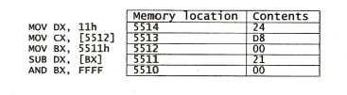
   * **FFF0h**
3. The number of nibbles in a word are:
   * **4**
4. In the Propeller microcontroller, the command “waitcnt(clkfreq*10 + cnt)” would cause the processor to do which of the following?
   * **Create 10 second delay**
5. The “LOOPNE” instruction is equivalent to which of the following instructions?
   * **DEC CX, JNE**
6. Given:

AX=FFE0 BX=3534 CX=0000 DX=0180 SP=FFEE BP=0000 SI=0000 DI=0000

DS=1D72 ES=1D72 SS=1D72 CS=1D72 IP=010D NV UP EI NG NZ NA PO NC

1D72:010D EB07 JMP 0114

How many bytes will the processor jump if the conditions for a jump were met?

* + **7**

1. On the Arduino platform, what is the programming language used?
   * **C**
2. What is the hexadecimal encoding for loading AX with a word (value) from the memory location 0820h?
   * **A12008**
3. Which of the following would be used to set the TRISA register to control the direction of the PIC18 Port to input?
   * **1**
4. The acronym ADC in microcontrollers stands for which of the following?
   * **Analog to Digital Converter**
5. In adding 5+5 through a 4 bit integer unit. The state of the OF and the CF flags after the add instruction would be:
   * **OF=1, CF=0**
6. Given:

0B0E:0200 57 65 6C 63 6F 6D 65 20-74 6F 20 74 68 65 20 66

0B0E:0210 69 72 73 74 20 64 61 79-20 6F 66 20 74 68 65 20

0B0E:0220 72 65 73 74 20 6F 66 20-79 6F 75 72 20 6C 69 66

0B0E:0230 65 00 00 00 00 00 00 00 00 00 00 00 00 00 00 00

An ASCII message begins at memory location 0200, what is the message?

* + **Welcome to the first day of the rest of your life**

1. The instruction MOV DX, BADD is what addressing mode?
   * **Immediate**
2. Which of the following is the hexadecimal encoding for adding BX with CX and storing the result in CX?
   * **03CB**
3. What is the advantage of Assembly Language over C Language?
   * **The Assembler creates much faster executable code**
4. What is 18.437510 in binary?
   * **010010.01110**
5. For the instruction sequence below, determine the contents of the register AL after this program is executed:
   * **51H**
6. In x86 architecture, ALU stands for which of the following?
   * **Arithmetic Logic Unit**
7. A microprocessor with a 33-bit address bus could access how much memory?
   * **8 GB**
8. What is the hexadecimal encoding for “JGE” for a jump back 12 bytes?
   * **7DF2**
9. Given:

AX=FFE0 BX=3534 CX=0000 DX=0180 SP=FFEE BP=0000 SI=0000 DI=0000

DS=1D72 ES=1D72 SS=1D72 CS=1D72 IP=010F NV UP EI NG NZ NA PO NC

1D72:010F 7D18 JGE 0128

How many bytes in decimal will the processor jump if the conditions for a jump are met?

* 1. **24**

1. Moore’s law has accurately predicted the growth rate in the number of transistors per die for the last 40 years. What is that rate?
   1. **Doubling every 18-24 months**
2. The number of bytes in a word are:
   1. **2**
3. Determine the contents of register BL after the following instructions have been executed:
   1. **2EH**
4. How many bit(s) is/are required to represent a range of decimal numbers from 0 to 127?
   1. **7**
5. What high level language is the propeller programmed in?
   1. **Spin**
6. In the Propeller microcontroller, the command “dira[4..9] := %000000” would cause the processor to do which of the following?
   1. **Sets the Propeller pins P4 through P9 as input pins**
7. Which command would you use to execute another core in the propeller microcontroller?
   1. **Cognew**
8. How many cores does the propeller microcontroller have?
   1. **8**
9. In the Propeller microcontroller, the command “waitcnt(clkfreq*10 + cnt)” would cause the processor to do which of the following?
   1. **Create 10 second delay**
10. The acronym ADC in microcontrollers stands for which of the following?
    1. **Analog to Digital Converter**
11. The acronym PWM used in the Parallax Propeller and Microchip PIC18, is defined as:
    1. **Pulse Width Modulation**
12. How many bits does the PIC18 microcontroller use in the PICkit 3 Debug Express have?
    1. **8**
13. Which of the following would be used to set the TRISA register to control the direction of the PIC18 Port to input?
    1. **1**
14. In the PIC18 with TRISD = 0b01111111, what is the configuration of the Port D?
    1. **Bit 7 of port D is set to output**
15. In the PIC 18 with TRISD = 0b11110000 and LATD = 0xAA, what value will be on Port D and shown on the LEDs?
    1. **0A**
16. On the Arduino platform, what is the programming language used?
    1. **C**
17. Given:

AX=FFD0 BX=3534 CX=0000 DX=0180 SP=FFEE BP=0000 SI=0000 DI=0000

DS=1D72 ES=1D72 SS=1D72 CS=1D72 IP=0111 NV UP EI NG NZ NA PO CY

1D72:0111 EB08 JMP 0119

What will the IP value be after a “t” command is executed in DOS Debug?

* 1. **0119h**

1. How many bytes are there in this short sequence of code? B4 00 CD 16 4C CD 21 CD 20
   1. **9**

**The world’s first microprocessor was developed in 1972 by?**

**Intel**

**RISC stands for**

**Reduce instruction set computer**

1. In x86 architecture, BIU stands for which of the following?
   1. **Bus Interface Unit**
2. Here is a short sequence of code: 74 13 EB A3 CD 16 7D 21 3C 04 EB F0 EB 15. All of the instructions are a word long. The fifth instruction operator is:
   1. **CMP**
3. The ASCII codes for space, space, carriage return, line feed, end of string in decimal are:
   1. **32, 32, 13, 10, 36**
4. A “NOP” instruction in a program will:
   1. **Perform a No Operation**
5. Given:

AX=FFF0 BX=3534 CX=0000 DX=0180 SP=FFEE BP=0000 SI=0000 DI=0000

DS=1D72 ES=1D72 SS=1D72 CS=1D72 IP=0109 OV UP EI PL NZ NA PO CY

1D72:0109 7D06 JNL 0118

What is the signed decimal value of the number in the AX register?

* 1. **-16**

1. Which of the following DOS Debug instructions would set a break point at memory location 010C?
   1. **G = 100 10C**
2. In adding 5+7 through a 4 bit integer unit, the state of the OF and CF flags after the add instruction would be:
   1. **OF = 0, CF = 0, ZF=0**
3. Given:

AX=FFD0 BX=3534 CX=0000 DX=0180 SP=FFEE BP=0000 SI=0000 DI=0000

DS=1D72 ES=1D72 SS=1D72 CS=1D72 IP=010D OV UP EI NG ZR NA PO NC

1D72:010D 7509 JNZ 0116

What will the IP value be after a “t” command is executed in DOS Debug?

* 1. **010Fh**

1. What are the contents of DX after this program has been run:
   1. **FFF0h**
2. Which of the following DOS Debug instructions would be used to change the IP register to 010C?
   1. **RIP**
3. What is the number, 1010.01012 in decimal?
   1. **10.31**
4. What command in DEBUG would be used to step through a program line by line?
   1. **T**
5. AND’ing 1FH and 02H will result in which of the following?
   1. **02**
6. How many address lines would be required to address 64 MB directly?
   1. **26**

If you want to use a INT software interrupt function to print a string out to the screen….

Ah = 09h, ds:dx, “$”, 21h

# S2010 MT2

1. How many bit(s) is/are required to represent a range of decimal numbers from0 to 127?
   1. **7**
2. If CX is 0003, what will CX be after a “LOOP” instruction?
   1. **0002**

If CX is 0002, what will CX be after a “LOOP” instruction?

* 1. **0001**

1. IN the Propeller microcontroller, the command “waitcnt(clkfreq*5 + cnt)” would cause the processor to do which of the following?
   1. **A 5 second delay**
2. What is the number 1011.01012 in decimal?
   1. **11.31**
3. This section of memory represents a stack. What type of program is this?

BEEF : FFD0 00 00 00 00 00 00 00 00-00 00 00 00 00 00 00 00

BEEF : FFE0 00 01 02 03 04 05 06 07-08 09 0A 0B 0C 0D 0E 0F

BEEF : FFF0 11 22 33 44 55 66 77 88-99 AA BB CC DD EE FF

* 1. **COM program**

1. With a POPA instruction, what will be the order of the accumulator, base, count, and data registers restored from the stack?
   1. **BDCA**
2. Determine the contents of register BL after the following instruction have been executed:
   1. **2EH**
3. What Hex values must be sent to address the key pad rows on the PPE board?
   1. **1, 2, 4, 8**
4. What is the number 32.437510 in binary?
   1. **100000.01110**
5. In MASM, with a “MOV CX, 18h” instruction, and a “LOOP” instruction, in decimal how many times will the program loop?
   1. **24**
6. The acronym PWM used for motor control, is defined as which of the following?
   1. **Pulse Width Modulation**
7. In the PIC18 with TRISD = 0b01111111, what is the configuration of the Port D?
   1. **Bit 7 of port D is set to output**
8. Given the short code, what is the value in AX after the program is run?
   1. **0500**
9. What flag(s) does the “LOOPNZ” instruction look at to determine whether to loop or not?
   1. **ZF**
10. How many nibbles are in double precision IEEE floating point format number?
    1. **16**
11. What type of program is this?

AX=0000 BX=0000 CX=0000 DX=0180 SP=FFEE BP=0000 SI=0000 DI=0000

DS=1476 ES=1576 SS=1376 CS=1D72 IP=0015 NV UP EI PL NZ NA PO NC

1376:0015 0100 ADD [BI + SI], AL DS : 0000=CD

* 1. **EXE**

1. If the SP is F00F, what is the SP value after a “PUSH CX” instruction?
   1. **F00D**
2. In the PIC18 with TRISD = 0b00001111 and LATD = 0xAA, what value will be on Port D and shown on the LEDs?
   1. **A0**
3. What is the numeric sequence of the key pad columns on the PPE board?
   1. **37, 2F, 1F**
4. What is –130 decimal in 2’s complement (8bits)?
   1. **01111110**
5. Which of the following is a valid x86 command for multiplying a number?
   1. **MUL BX**
6. The number of bits in single precision IEEE floating point format are:
   1. **32**
7. You are trying to rebuild a HELLO project program in MASM and you get the following error:

“LINK : warning L4021: no stack segment”.

What would be the reason for such an error?

* 1. **No project template for COM was selected**

1. A “pull down” resistor is used in digital circuits to do what?
   1. **To keep the signal line “tied” low until the line is active (goes high)**
2. A “POP” instruction:
   1. **increments the SP**
3. AND’ing 10H and 2FH will result in which of the following?
   1. **0**
4. In the Propeller microcontroller, the command “dira[4..9] := %111111” would cause the processor to do which of the following?
   1. **Sets the Propeller pins P4 through P9 as output pins**
5. What commands in MASM-CodeView would be used to step through a program line by line?
   1. **T (F8)**
6. If the SP is F00F, what will the SP value be after a “POP SP” instruction?
   1. **F011**
7. On the PPE board, what number(s) on the key pad is(are) pressed for an output port value of 08h and an input port value of 2Fh?
   1. **0**
8. In the Propeller microcontroller, the term “Method” is(are) which of the following?
   1. **A block of executable commands that has variables, can receive parameters, and returns a value.**
9. Using MASM, which of the following will cause a program with a LOOP instruction to loop 48 times in decimal?
   1. **MOV CX, 30H or MOV CX, 48**
10. A “pull up” resistor is used in digital circuits to do what?
    1. **To keep the signal “tied” high until the line is active (goes low)**
11. 1010 0110 in 2’s complement equals in base 10 ➔ **-90**
12. A microprocessor with a 32-bit address bus could access how much memory➔ **4GB**
13. A microprocessor with a 24-bit address bus could access how much memory➔ **16MB**
14. A6 in 2’s complement equals in base 10 ➔ **-90**
15. A “POP” instruction: ➔ **Increments the SP**
16. A “PUSH” instruction ➔ **decrements the SP**
17. A “NOP” instruction in a program will ➔ **Perform a No Operation**
18. AND’ing 1FH and 02H will result in which of the following ➔ **02**
19. AND’ing 10H and 2FH will result in which of the following ➔ **0**
20. A “**pull down**” resistor is used in digital circuits to do what? ➔ **To keep the signal line “tied” low until the line is active (goes high)**
21. A “**pull up**” resistor is used in digital circuits to do what ➔ **To keep singal “tied” high until the line is active (goes low)**
22. Determine the contents of register BL after the following instructions have been executed:➔ **E2H**
23. MOV BL, E2H
24. MOV CL, 1000b
25. Mov CL, SI is what addressing mode  **REGISTER**
26. ROL BL, CL **; rotate BL by 8 to left = same value**
27. For the instruction sequence below, determine the contents of the registers AL after this program ➔ **51H**
28. MOV AL, 73h ; 0111 0011
29. ADD AL, 78h ; 0111 1000
30. DAA
31. if low nibble of AL > 9 or AF = 1 then:
32. AL = **AL + 6**
33. AF = 1
34. if AL > 9Fh or CF = 1 then:
35. AL = **AL + 60h**
36. CF = 1
37. For the instruction sequence below, determine the contents of the register AL after this program is executed ➔ **51H**  
     MOV AL, 83h ADD, AL, 68h
38. DAA
39. Given the short code, what is the value in AX after the program is run ➔ **0100** Mov BX, 0100 PUSH BX MOV AX, 0500 POP AX
40. Given the short code, what is the value in AX after the program is run ➔**0001** MOV BX, 0001
41. PUSH BX
42. MOV AX, 0500
43. POP AX
44. GIVEN: IP = 0106 Flags: NV UP EI NG NZ NA PE NC Instruction: JMP 011F
45. What will the IP value be after “t” command is executed in DOS Debug? ➔ **011FH** (Unconditional Jump)
46. GIVEN: IP = 0109 Flags: OV UP EI PL NZ NA PO CY Instruction: JGE 0118
47. What will the IP value be after a “t” command is executed in DOS Debug ➔ **010B**
48. (0109 + 0010 add two bytes)
49. GIVEN: IP=FFE0 Flags: OV UP EI PL NZ NA PO NC Instruction: JGE 0116: ID72:010D 7D**09**
50. How many bytes will the processor jump if the condition for a jump were met? ➔ **9**
51. GIVEN: AX= FFF0 IP = 0109 FALGS: OV UP EI PL NZ NA PO CY ID72: 010F **7D18** Instruction: JGE 0118. What is the signed decimal value of the number in the AX register? ➔ **-16**
52. Covert the number 7D18 into decimal.
53. GIVEN: IP= 010F Flags: NV UP EI NG NZ NA PO NC Instruction: JNL 0115.
54. How many bytes in decimal will the processor jump if the conditions for a jump were met ➔ **24**
55. GIVEN: 57 65 6C 63 6F 6D 65 20-74 6F 20 41 73 73 65 6D
56. 62 6C 79 20 4C 61 6E 67-75 61 67 65 00 00 00 00
57. An ASCII message begins at memory location 0200, what is the message? ➔ **Welcome to Assembly Language**
58. Here is a short sequence of code: 7413 EBA3 CD16 7D21 3C04 EBF0 EB15. All of the instructions are a word long. The third instruction operator is ➔ **INT**
59. Here is a short sequence of code: 7413 A3EB CD16 7D21 3C04 EBF0 EB15. All of the instructions are a word long. The fourth instruction operator is ➔**JGE**
60. Here is a short sequence of code: B400 CD16 3C4A 7404 BC6A 7513. All of the instructions are two bytes long. The sixth instruction operator is ➔**JNZ**
61. How many cores does the propeller microcontroller have ➔ **8**
62. How many bits(s) is/are required to represent a range of decimal numbers from **0** to **15** ➔ **4**
63. How many bits(s) is/are required to represent a range of decimal numbers from **0** to **63** ➔ **6**
64. How many bits(s) is/are required to represent a range of decimal numbers from **0** to **127** ➔**7**
65. How many bits(s) is/are required to represent a range of decimal numbers from **0** to **255** ➔**8**
66. How many bytes are there in this short sequence of code B4 00 CD 16 4C CD 20 ➔ **7**
67. How many nibbles are there in this short sequence of code B4 00 CD 16 3C 4A 74 04 3C 6A 75 13 ➔**24**
68. How many bytes are in double precision IEEE floating point format numbers → **8**
69. How many nibbles are in double precision IEEE floating point format numbers → **16**
70. How many address lines would be required to address 128 MB directly ➔ **27** (128 x 1048576 = 134217728 and 2^27 = 134217728)
71. How many address lines would be required to address 64 MB directly ➔ **26** (64 x 1048576 = 67108864 and 2^26 = 67108864)
72. If CX is 0000, what will CX be after a “LOOP” instruction ➔ **FFFF**
73. If CX is 0003, what will CX be after a “LOOPNZ” instruction ➔**0002**
74. If the SP is **F00F**, what is the SP value after a “**PUSH CX**” instruction ➔ **F00D**
75. If the SP is **F00F**, what is the SP value after a “**POP CX**” instruction ➔ **F011**
76. If the SP is **F00F**, what is the SP value after a “**POP SP**” instruction ➔ **F011**
77. In adding 5+5 through a 4 bit integer unit. The state of the OF and CF flags after the add instruction would be ➔ **OF = 1, CF = 0**
78. In x86 architecture, BIU stands for which of the following ➔ **Bus Interface Unit**
79. In x86 architecture, ALU stands for which of the following → **Arithmetic Logic Unit**
80. In the x86 lab part 3 Hello MASM program in the original code, what is the address of the byte used to start the number in the sequence “Hello World 0”? ➔ **020E**
81. In MASM, with a “MOV CX, **24h**” instruction, and a “LOOP” instruction, how many times will the program loop in decimal ➔ **36**
82. In MASM, with a “MOV CX, **24**” instruction, and a “LOOP” instruction, how many times will the program loop in decimal ➔ **24**
83. In MASM, with a “MOV CX, 12h” instruction, and a “LOOP” instruction, how many times will the program loop in decimal ➔ **18**
84. In the Hello MASM lab in the original code, what is the address of the string to start the message “Hello World 0” ➔ **0200**
85. In the PIC18 with TRISD = 0b10000000, what is the configuration of the Port D ➔ **Bit 7 of port D is set to input**
86. In the PIC18 with TRISD = 0b01111111 and LATD = 0xAA, what value will be on Port D and shown on the LEDS ➔ **Bit 7 of port D is set to output** (because the first bit is zero = output)
87. In the PIC18 with TRISD = 0b00001111, what is the configuration of the Port D ➔ **A0 (First 4 are outputs and last four are inputs)**
88. In the PIC18 with TRISD = 0b11110000 and LATD = 0xAA, what value will be on Port D and shown on the LEDS ➔ **0A**
89. In the Propeller microcontroller, the command “dira[9..4] := %000000” would cause the processor to do which of the following ➔ **Sets the propeller pin P4 through P9 as output pins**
90. In the Propeller microcontroller, the command “dira[9..4] := %111111” would cause the processor to do which of the following ➔ **Sets the propeller pin P4 through P9 as output pins**
91. In the propeller microcontroller, the command “waitcnt(clkfreq*3 + cnt)” would cause the processor to do which of the following ➔ **A 3 second delay**
92. In the propeller microcontroller, the command “waitcnt(clkfreq*2 + cnt)” would cause the processor to do which of the following ➔ **A 2 second delay**
93. In the Propeller microcontroller, the term “Method” is (are) which of the following ➔ **A block of executable commands that has variables, can receive parameters, and returns a value.**
94. Int 10h uses what function code to write a character to the screen and advance the cursor by one character position ➔ **0Eh**
95. Int 21h, Function 09h requires three things set up before calling in order to correctly print a string:
96. **DS=SEG Hello_msg, DX=OFFSET Hello_msg, Hello_msg terminated with 24h**.
97. Ladder Logic is used in? ➔ **PLCs**
98. **Moore’s law** has accurately predicted the growth rate in the number of transistors per die for the last 40 years. What is the rate? ➔ **Doubling every 18-24 months**
99. On the Ardino platform what is the program language used ➔ **C**
100. On the **PPE board**, what numbers(s) on the key pad is(are) pressed for an output port value of 08h and an input port value of 2Fh ➔ **0**
101. On the **PPE board**, what numbers(s) on the key pad is(are) pressed for an output port value of 04h and an input port value of 2Fh ➔ **8**
102. The “LOOPNZ” instruction is equivalent to which of the following instructions ➔ **DEC CX, JNE**
103. The acronym PWM used for motor control, is defined as which of the following ➔ **Pulse Width Modulation**
104. The acronym PLC, is defined as which of the following? ➔ **Programmable Logic Controller**
105. The ASCII codes for space, space, carriage return, line feed, end of string in **decimal** are ➔ **32, 32, 13,10, 36**
106. The ASCII codes for space, space, carriage return, line feed, end of string in **hexadecimal** are:→ **20,20,0D,0A,24**
107. The binary number, 1011 0101, represents what values as a unsigned binary, 8 bit signed binary, odd parity ASCII, and BCD number (in that order) **➔ 181, -76, 5, invlaid5**
108. The binary number, 1000 0101, represents what values as a unsigned binary, 8 bit signed binary, odd parity ASCII, and BCD number (in that order) **➔ 133, -123, ENQ, 85**
109. The instruction MOV CX, DADD is what addressing mode ➔ **Immediate**
110. The instruction MOV CX, [DADD] is what addressing mode ➔ **Direct**
111. The number of bits in single precision IEEE floating point format are → **32**
112. This section of memory represents a stack. What type of program is this ➔ **EXE PROGRAM** **BEEF:00D0** 00 00 00 00 00 00 00 00-00 00 00 00 00 00 00 00 **BEEF:00E0** 00 01 02 03 04 05 06 07-08 09 0A 0B 0C 0D 0E 0F **BEEF:00F0** 11 22 33 44 55 66 77 88-99 AA BB CC DD EE FF
113. This section of memory represents a stack. What type of program is this ➔ **COM PROGRAM** **BEEF:FFD0** 00 00 00 00 00 00 00 00-00 00 00 00 00 00 00 00 **BEEF:FFE0** 00 01 02 03 04 05 06 07-08 09 0A 0B 0C 0D 0E 0F **BEEF:FFF0** 11 22 33 44 55 66 77 88-99 AA BB CC DD EE FF
114. Using MASM, which of the following will cause a program with a LOOP instruction to loop 48 times in decimal ➔ **MOV CX, 48**
115. Which command would you use to execute another core in the propeller microcontroller➔ **Cognew**
116. What command in DEBUG would be used to change the code segment ➔ **RCS**
117. What command in DEBUG would be used to change the IP value ➔ **RIP**
118. What command in DEBUG would be used to execute interrupts ➔ **P**
119. What command in MASM-CodeView would be used to step through a program line by line ➔ **T(F8)**
120. What flag(s) does the “LOOPNZ” instruction look at to determine whether to loop or not ➔ **ZF**
121. What flag(s) does the “LOOPNE” instruction look at to determine whether to loop or not ➔ **ZF**
122. What Hex values must be sent to address the key pad rows on the PPE board ➔ **1,2,4,8**
123. What is the advantage of C Language over Assembly Language ➔ **C is transportable to other microprocessor architectures**
124. What is the hexadecimal encoding for “JGE” for a jump back 10 bytes ➔ **7DF2**
125. What is the hexadecimal encoding for adding AX with BX and storing the result in AX ➔ **01D8**
126. ADD AX, BX 000 00W 11 reg1 reg2
127. What is the hexadecimal encoding for adding BX with DX and storing the result in BX ➔ **01D3**
128. What is -130 decimal in 2’s complement (8bits) ➔ **01111110**
129. What is -32.75 in a base two number system ➔ **-100000.110000**
130. What is 16.4375 in binary ➔ **010000.01110**
131. What is the binary value of decimal 12.875 ➔ **1100.1110**
132. What is 16.4375 in binary → **010000.01110**
133. What is number, 1011.0101 (2) in decimal? ➔ **11.31**

What is the hexadecimal encoding for lading AX with a word (value from memory location 0820h

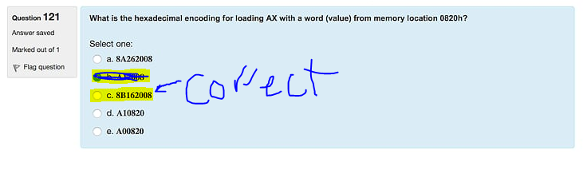

1. What is the **numeric sequence** of the key pad columns on the PPE board ➔ **37,2F,1F**
2. What is the decimal value of C5 5A 57 00 in IEEE single precision FP format → **-3493.4375**
3. What of the following instruction would be used to set the LED to light on the Arudino platform ➔ **digitalWrite(ledPin, HIGH);**
4. What type of program is this ➔ **EXE** IP = **0115**, 1376:0115 0100 ADD [BX+SI], AL DS:0000=CD
5. What type of program is this ➔ **COM** IP = 0100, 1376:0100 0100 ADD [BX+SI], AL DS:0000=CD
6. Which of the following DOS Debug instructions would set a break point at memory location 010C ➔ **G = 100 10C**
7. Which of the following would be used to set the **TRISA** register to control the direction of **PIC18** port to **input** ➔ **1** and for **output** its ➔ **0**
8. Which of the following DOS Debug instructions would be used to change the IP register to 110 ➔**RAX = 0110**
9. What is 458752.00 Converted to double precision FP?
   1. 41 1c 00 00 00 00
10. Which of the following will cause a program with a LOOP instruction to loop 48 times (decimal)➔ **CX=30h**
11. Which of the following is a valid x86 command for multiplying a number ➔ **MUL BX**
12. Which of the following is **not a valid** command for a number into a register in MASM ➔ **MOV AX, BADH**
13. With a POP BX instruction, what will be order off the accumulator, base, count, and data registers restored from the stack ➔ **BX**
14. With a POPA instruction, what will be the order of the accumulator, base, count, and data registers restored from the stack ➔ **BDCA**
15. You are trying to rebuild a HELLO program project in MASM and you get the following error: "ERROR 4 line 1". What is the cause of the error? ➔ **Not known—this error by itself isn’t a problem, press the enter key to clear the error.**
16. You are typing to rebuild a HELLO project program in MASM and you get the following error: “LINK : warring L4021: no stack segment”. What would be the reason for the such an error ➔ **No project template for COM was selected.**
17. You are typing to rebuild a HELLO project program in MASM and you get the following error: “LINK : fatal error L1089: HELLO.lrf: cannot open response file”. What would be the reason for the such an error ➔ **No source file is identified(no .asm file)**
18. **PPE** **Row Column** [**Scan**](https://moodle.ecs.csus.edu/file.php/107/LectureNotes/Lecture12/174lecture12_files/ppe-rowcolumnscandecoding2_7.pdf) **decoding**  
        D7 D6 D5 D4 D3 D2 D1 D0  
        S7 S6 S5 S4 S3 S2   
        ^ ^ ^   
        3 2 1  
        0 0 0 0 1 0 0 0 = 08h  
        0 0 0 1 0 0 0 0 = 10h  
        0 0 1 0 0 0 0 0 = 20h  
          
        0 0 1 1 1 1 1 1 = 3Fh -> Nothing pressed  
        0 0 1 1 0 1 1 1 = 37h -> Number 1 pressed  
        0 0 1 0 1 1 1 1 = 2Fh -> Number 2 pressed  
        0 0 0 1 1 1 1 1 = 1Fh -> Number 3 pressed

**Flags**

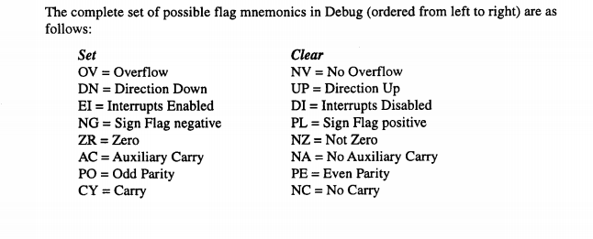

**Jump information**

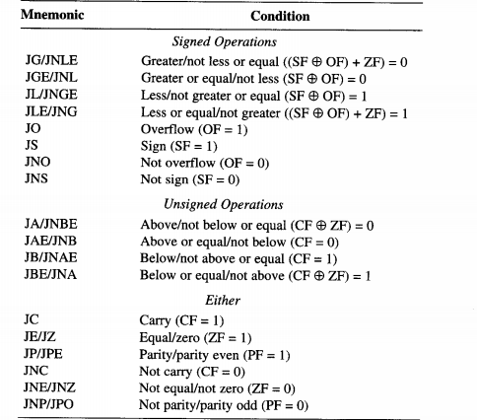

**Jumps always start with 7…**

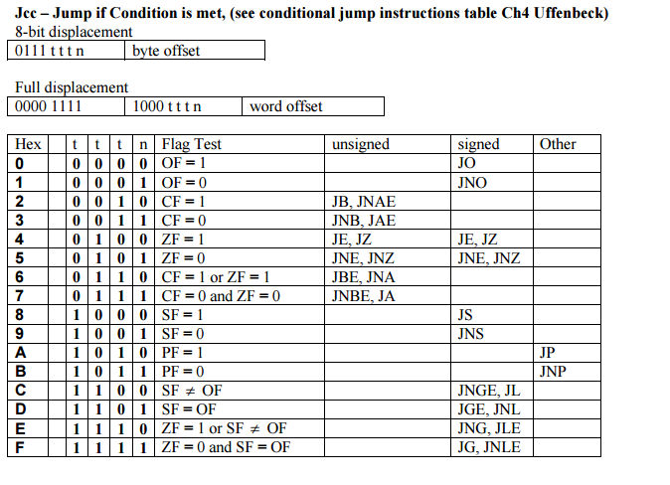

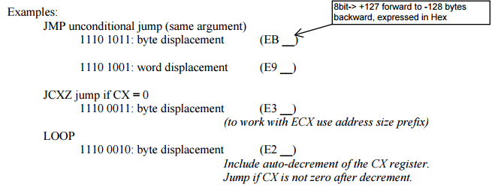

**Link to a converter**

**http://www.exploringbinary.com/floating-point-converter/**